“How to..” for TM Crew? – including Timesheet and Work & Leave
Table of Contents
“How to..” for TM Crew? 1
How to add a deck? 3
How to add a lifeboat? 3
How to add a muster station? 3
How to add a muster station role to a muster station? 4
How to add a cabin? 5
How to add a bunk to a cabin? 6
How to assign a bunk to a crew member? 6
How to link a muster station role to a bunk? 7
How to add a crew member? (With a licensed Crew module) 8
How to add “Contact details” to a crew member? 9
How to add a crew member’s next of kin 10
How to sign on a crew member? 11
How to sign off a crew member? 12
How to sign on/off multiple crew members? 14
How to plan a trip for a Crew member? 15
How to plan a trip for multiple crew members? 16
How to plan an activity for a crew member? 17
How to see the planned trips or activity for a crew member? 17
How to link a TM Master v2 user to a crew member? 20
How to update your own crew information? 21
The Timesheet detail view 22
How to find the timesheet detail view 23
How to add work entries in the timesheet pane 24
How to add work entries in the paint pane. 25
How to turn the Timesheet pane and the paint pane on and off. 25
How to change the shown date range for timesheet. 25
How to calculate conformance 26
How conformance is shown 26
How to add work periods for several days at once 26
How to generate the hours of rest report 27
How to view the change history for the timesheet 29
How to confirm work period entries 29
How to cancel confirmation of work period entries 29
Consistency of confirmation: 30
The TimeSheet overview 31
How to review timesheet data in the Timesheet overview. 32
How to Approve work period entries 32
How to Set work period entries as processed 32
How to set up Timesheet for the fleet 33
How to Import Time Sheet regulations 33
How to Set the default regulation set date range 34
How to Set the regulation set date range for specific units 35
Reference Section 36
How to set user rights in the Crew module? 36
How to add crew related codes? 38
Crew Module – Work & Leave Calculation. 39
Manual Adjustments for Work & Leave 40
How the Leave totals are calculated 41
How Activities affect the work & leave calculations 42
The Calendar Day Setting for Work & leave 43
Unit Overview for Work / Leave 44
Information about Work Hour Categories (Timesheet) 45
Information about the time sheet user rights 46
Confirming, Approving and Processing 47

Revision Date: 05.04.2022
How to add a deck?
- Click [Ship] [Details] “Deck” tab.
- Click [New Deck]
- Enter a name for the deck.
Decks are currently being used to assign locations for cabins and muster stations
Note: This can also be done from the Ship Location module by adding a root node to the location structure and selecting ‘Deck’ as the type.

How to add a lifeboat?
- Click [Ship] [Details] “Lifeboats” tab.
- Click [New lifeboat]
- Enter a name for the lifeboat
Lifeboats can be designated for a cabin, which automatically assigns all crew members within the cabin to the lifeboat.

How to add a muster station?
- Click [Ship] [Muster station]
- Click [New] (Top left corner)
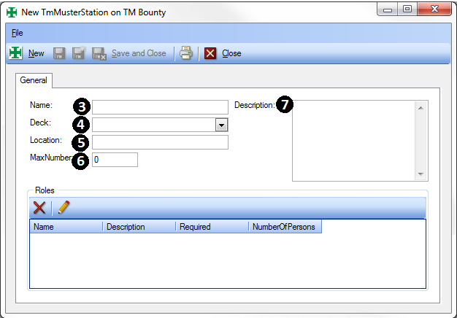
- Enter a name for the muster station
- Assign which “deck” the muster station is located on.
- You can enter a more specific location, if required
- You can enter the maximum number of people the muster station can accommodate
- You can also add a description of the muster station if needed
- To add muster station roles see “How to add a muster station role to a muster station”

How to add a muster station role to a muster station?
- Click [Ship] [Muster station] Double click the muster station to add roles or create a new one as described in “How to add a muster station?”
- Click the [Edit grid] button (Icon: Pencil), and a new line will appear in the list box below
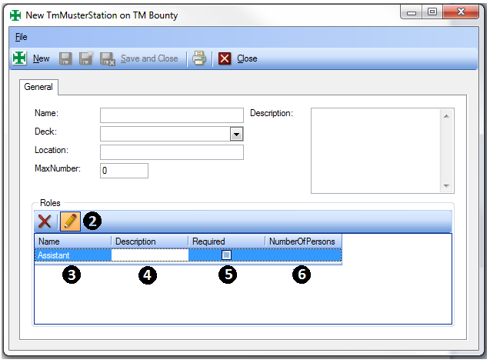
- Click beneath the Column header “Name” and select one of the predefined roles. The values in this drop down, can be added as codes in the “roles” code table. How to do this is described in “How to add new codes?”
- Enter a short description of the role
- If the role is required, tick the check box under the column head “Required”.
- Enter the number of crew members that this role on this muster station can be assigned to.
- When the muster station role has been defined, press enter to add it to the muster role list.
- You can now by performing step 3-7 add more roles for this muster station.
To edit an existing role make sure the [Edit grid] button is toggled “on” and click the record you want to update
To delete a muster station role select it and click the [Delete] button (icon: Red X), found on the menu bar

How to add a cabin?
- Click [Ship] [Cabins]
- Click [New] (Top left corner)
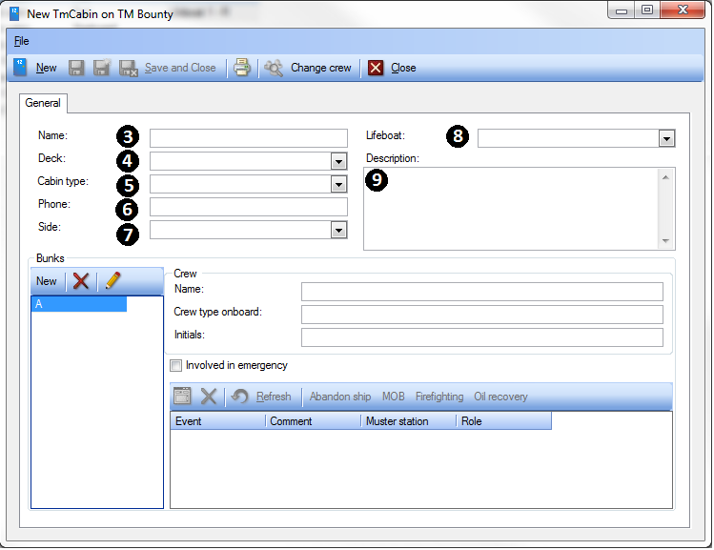

- Enter a name for the cabin
- Assign which deck the cabin is located on
- Select a cabin type*, describing the cabin.
- Enter the cabins phone number
- Assign the side* the cabin is located
- Select the designated lifeboat for the crew using this cabin.
- You can also include a description of the cabin if required.
* The values in these dropdowns must be added as codes. How to do this is described in “How to add new codes?”

How to add a bunk to a cabin?
- Click [Ship] [Cabins]
- Double click the cabin you want to add a bunk to or create a new one
- In the lower left corner is a section called “bunks”
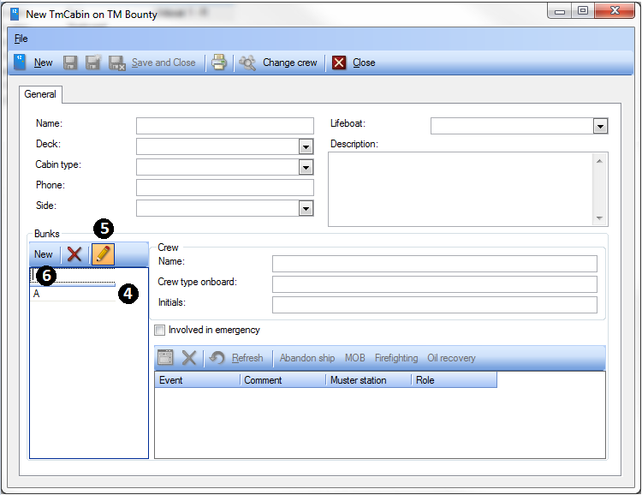
- A cabin when created will by default contain one bunk called “A”
- To create a new bunk click [New] in the “Bunks” section
- Enter the bunk’s name, and click [OK].
To edit a bunk click the [Edit grid] button (icon: Pencil), click the bunk you want to edit, and alter it.
To delete a bunk select the bunk and click [Delete] (Icon: red X)

How to assign a bunk to a crew member?
There are several ways of assigning a crew member to a bunk, the following steps describes how you can do it from the cabin dialog.
- Click [Ship] -> [Cabins]
- Double click the cabin you want to assign to a crew member
- Select the bunk you want to assign a crew member to.
- Click the [Change crew] button
- Select the Crew member and Click [OK]
- Click [Save and close]

How to link a muster station role to a bunk?
In TM Master V2, muster station roles are linked to bunks, and the crew assigned to these bunks, are also assigned the attached muster station roles.
- Click [Ship] [Cabins]
- Double click the cabin containing the bunk you want to assign a muster station role to.
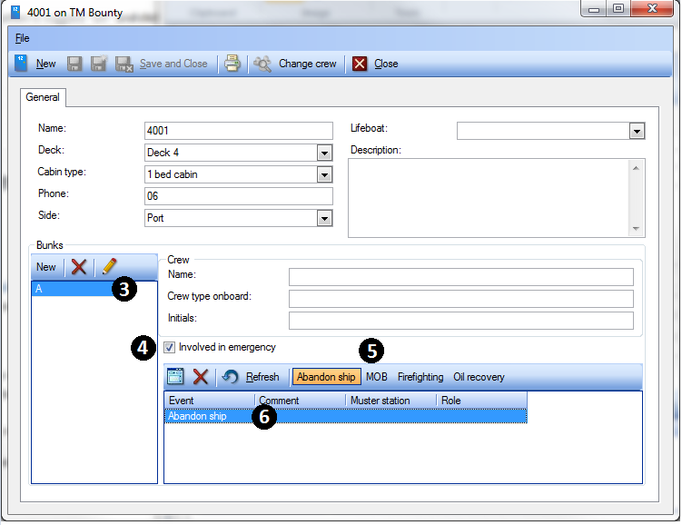
- Select the bunk you want to assign a muster station role.
- Tick the “Involved in emergency” check box.
- Click the emergency type* the muster station role you wish to assign, applies to.
* The different emergency types are defined as codes, and how to add values to this list is described in “How to add codes”
A record in the selected emergency type will appear in the emergency event list.
- Double click the event record
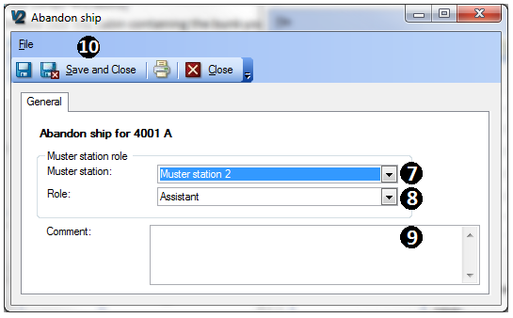
- Select the muster station for the event.
- Select the role the crew member in this bunk should assume at the selected muster station.
- In the comments field you may add more details for the crew’s tasks/responsibilities if the emergency event should occur.
- Click [Save and Close]
If the crew in the selected bunk should be involved in any other “emergency” events repeat step 5-11 to add another emergency event.
If the crew member is assigned to a bunk with an emergency event attached, and for some reason it does not apply to the current crew, you can deactivate the emergency event role link by clicking the emergency event. Later you can reactivate the emergency event role by clicking the event again.
To delete an emergency event record, select it and click [Delete] (icon: Red X)

How to add a crew member? (With a licensed Crew module)
- Click [Crew] [Crew list]
(If in the office, you can also click[Fleet] [Crew list])
- Click [New] (Top left corner)

- Enter the crew member’s information.
- Enter Crew name (first, middle and last name (surname))
- Select “Gender”, “Marital status*” and “Nationality*”

- If the crew member is directly employed by your company, then tick the ‘Is Employed’ check box.
(if left empty crew member is grouped as “Others” in the [Crew] [Overview])

- If the crew member is willing to take extra shifts, tick the “Available as stand in”

- If the crew has watch duties, tick the “Watch duties” check box.
(This information is used in the “Hours of Work/Rest” report)

- Enter the crew member’s “Employee number”
- Select the crew members “watch*”
- Discharge book information (Number, Issue date, expiry date)
- Status: You may choose between two initial crew statuses “On leave” or “Inactive”
To set this status to “Signed On” see “How to sign on a Crew member”
- “Onboard now”, will show the current vessel the crew member is signed on, once signed on.
- “Onboard as” will show which crew type the crew member is signed on as.
- Select the “Default unit” for the crew member, this will affect which vessel’s crew list he/she is listed under when signed off. When signing the crew member on, this vessel will come up as the default vessel.
- Select the crew’s home airport if applicable
- Select the “default crew type*” for the crew member. You may still sign a crew member on as a different crew type if required later on.
- Travel specific comments, are meant for notes on the crew members travel preferences etc.
- You can enter the crew member’s bank specific information if needed
- Custom declaration details are described in “How to add custom declaration?”
- Passport information is added under the “Passport” tab.
- Passport number
- Issue date
- Issued by
- Expires date
- Place of birth
- The measurement tab allows you to add specific measurements.
- Weight, is used in the “Helicopter list” report, to calculate the total weight of departing/arriving crew members.
- Height
- Blood group
- Size of collar
- Size of boiler suit
- Size of boots (and size uom)
- Click [Save and Close]
It is possible to allow the individual crew member to update all or part of his/her own crew information. This is described in “How to allow crew members to update their own crew information?”

How to add “Contact details” to a crew member?
- Click [Crew] [Crew list]
(If in the office, you can also click[Fleet] [Crew list])
- Select and double click the Crew member you want to add contact details to.
- Click the “Contact details” tab
This form is exactly the same form used to describe a “Company Contact”, and if you link the crew member to a company, by clicking the […] button in the company field, the crew member will also be listed as a contact for the selected company. (In the TM Master V2 [Contacts] list (address list))
If you already have a registered contact person in the [Contacts] list, you can convert this contact into a crew member, by double clicking the contact in [Inventory] [Contacts], and then clicking the [Open contact’s crew details..], found in the top menu. This will then ask you if you want to create a crew record for this contact, if one does not already exist.
More details regarding contact persons can be found under “How to add a contact person?”
How to add a crew member’s next of kin
- Click [Crew] [Crew list]
(If in the office, you can also click[Fleet] [Crew list])
- Select and double click the crew member you want to alter.
- Click on the “Next of kin” tab
- Click the “New next of Kin” button in the upper left hand corner BELOW the tabs and add the required information.
- Select the crew members relationship * to this next of kin
- First, middle and last name
- Click [OK] and continue to add further details if the information is available
- Job title
- Date of birth (The age will be calculated)
- Work and home phone numbers
- Home address, tick the “Same address” check box to add the crew member’s address to the next of kin record.
- Remember to save when done.
If more than one next of kin is added, you can prioritise them by shifting their position in the
next of kin list. You can use the blue arrow buttons (either up or down) to change the priority of contact record
A next of kin can be edited by
1. Select the person from the “Next of kin list” list
2. Edit the next of kin information, to the right of the list.
* The different relationship types are defined as codes, and how to add values to this list is described in “How to add codes”

How to sign on a crew member?
To sign on a crew member in the vessels [Crew list] please do the following.
- Click [Crew] [Crew list]
- Select and right click the crew member, currently on leave or inactive, you want to sign on.
You can see the crew’s current status indicated by coloured balls in the status column
(Green = Signed on, Yellow = On leave, Red = Inactive)
- Select “Sign on/off”
A dialog regarding the sign on will appear
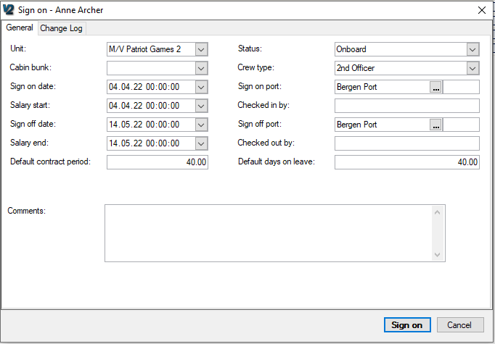
- Unit : The vessel you are signing the crew onto will show
- Cabin bunk : Select the bunk the crew member is assigned (Only available bunks are shown)
- Sign on date: Select the date and time for the sign on.
- Salary start: Select the date and time for the salary start.
- Sign off date: If you already know the sign of date you can enter the date and time now.
(When signing the crew off you will be able to change the sign off date and time.)
- Salary end: Select the salary end date and time
(When signing the crew off, you will be able to change the salary end date and time.)
- Crew type: Select the “crew type” the crew member is signing on as, the preselected value is the crew members default crew type, but a crew member may sign on as a different crew type.
- Sign on port: Select which port the crew is signing on from by clicking the […] button, a list will then appear with all “contacts” marked as “Port”
(please refer to “How to create a contact for more details on how to create a “Contact” for more details)
- Sign off port: Select the port where the crew will sign off.
(When signing the crew off you will be able to change the sign off port if necessary.)
- Comment: Add any additional comments about the sign on.
- Click [Sign On]
The crew member should now be signed on, you can see this in the crew list indicated by the green status indicator.
Note: Salary Start and Salary End are used to define the start and end of work periods, for the purposes of calculating work and leave.

How to sign off a crew member?
- Click [Crew] [Crew list]
- Select and right click the crew member, currently signed on, that you want to sign off.
You can see the crew’s current status indicated by coloured balls in the status column
(Green = Signed on, Yellow = On leave, Red = Inactive)
- Select “Sign on/off”
A dialog regarding the sign off will appear
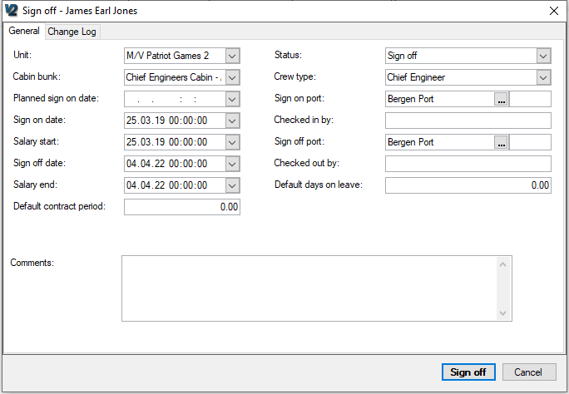
- Unit : The vessel that the crew is currently signed on
- Cabin bunk: The bunk the crew member is currently assigned
- Sign on date: Is the date and time the crew was signed on
- Salary start: The date set during sign on as salary start date
- Sign off date: Is the sign off date indicated at sign on. If not set on sign on, it will set todays date. You can edit the sign off date and time to a date in the past or a date in the future. If the sign out date is not today this will be indicated by a blue triangle, and you will need to confirm that the sign out is not “today”, after clicking the [Sign out] button.
- Salary end: The date and time when the crew member’s salary is stopped, this can be adjusted to a date in the past or the future. The value when signing out is either the date set on sign on or, if not set on sign on, today’s date.
- Signing off: Here you can select which status the crew member should have after the sign out. You currently can choose between “On leave” or “Inactive”.
- Crew type: This is the crew type the crew member was sign on as.
- Sign on port: The port the crew was singed on
- Sign off port: The port the crew member was, at sign on, planned to sign off on. If empty no port was selected on sign on. You can change the port if necessary.
- Comments: Comments from the sign on, and you can add a comment on the sign off.
- Click [Sign Off]
Note: Salary Start and Salary End are used to define the start and end of work periods, for the purposes of calculating work and leave.

How to sign on/off multiple crew members?
- Click [Crew] [Crew list]
- Select the crew members you want to sign on or off. By holding the [CTRL] key on your keyboard and you can select more crew members at the same time. You can select both crew signing on and signing off, but you should sign crew members off before signing others on to make the bunks available.
- Either right click one of the selected crew members and select “Sign on/off” or click the [Sign on/off] button in the menu bar.
A dialog regarding the sign on/off will appear.
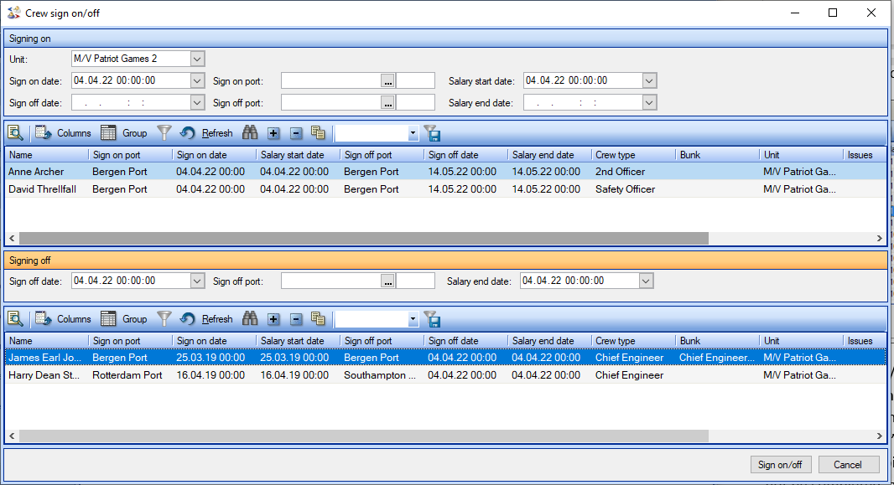

- Change the sign on/off details directly in the grid, by clicking the field you want to change.
The different columns are the same fields as described in step 3 in “How to sign on a crew member”. Except the “comment”, but you can open the “trip” and add this later on if nessesary
- The column “Issues” will let you know of any conflicts such as “Sign on is not today” , and “Cabin bunk already occupied” or “OK” if no conflicts are detected. If text is red the sign out/inn can not be completed, and has to be addressed.
- When all Sign On/Off data has been selected, click [Sign on/off].

How to plan a trip for a Crew member?
Planning a trip for a crew member can be done in all views where crew members are listed.
- Click [Crew] [Crew list]
- Click [Plan new trip] in the top menu bar.
The following window will appear.
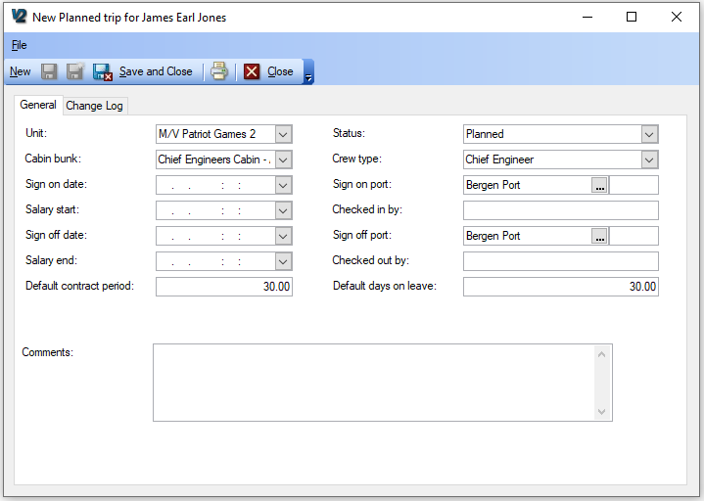
- Select the Unit (or vessel) the planned sign on is for.
- Select the Cabin\bunk the crew member will use
- Select the planned sign on date and time
- Select the salary start date and time
- Select the planned sign off date and time.
- Select salary end date and time.
- Status: Is informing you that you are working on a planned sign on.
- Select the crew type the crew member will sign on as.
- Select Sign on and Sign off port.
- Add any comments on the planned sign on if desired.
- Click [Save and Close]

How to plan a trip for multiple crew members?
Planning trips for multiple crew members can also be done as for single crew members in all views listing crew members.
- Click [Crew] ]Crew list]
- Select the crew members you want to plan a trip for.
(Press and hold the [CTRL] key, and select the crew members)
- When the crew members you wish to plan a trip for is selected, click [Plan trip]
The following window will appear.
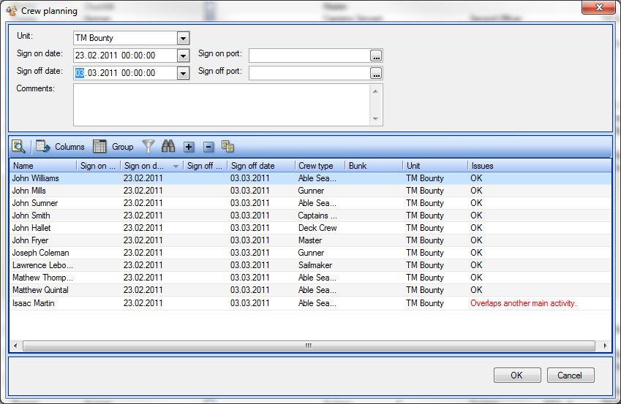
All the following selections are set for all the selected crew members
- Select the unit / vessel the planned trip is for
- Select Sign on and Sign off date
- Select sign on and sign off port
- Add a comment to the planned trip
- Click [OK]
The selected crew members will by default be signing on as their default crew type
If a crew member has a trip or activity already planned in the selected period, you will be notified by a comment (in red), in the “Issues” column.

How to plan an activity for a crew member?
An “Activity” can be used to register “non trip” related activities, such as courses etc.
- Click [Crew] [Crew list]
- Select the crew member you wish to add an activity to.
- Click the [Add activity] button in the top menu.
The following view should appear.

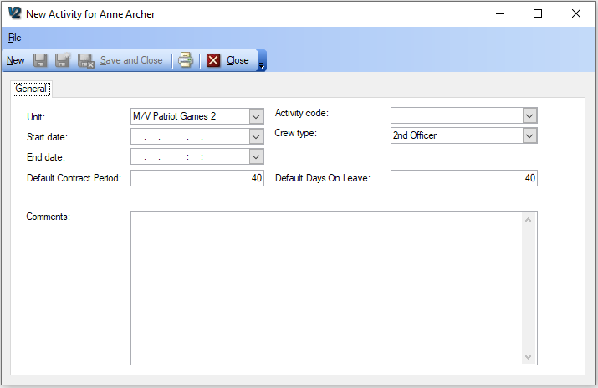

- Select the unit/vessel the activity is related to.
- Select the start date and end date for the activity.
- Select an “activity code”
- Add a comment to the activity
Note: Activities can affect the calculation of Work & Leave, depending on the type of activity. This is covered in more detail in the sections about work and leave.

How to see the planned trips or activity for a crew member?
There are multiple ways to see planned trips and activities
- View trip and activities list pr. crew member
The following can be done in any view listing crew members.
- Click [Crew] [Crew list]
- Double click the crew member you want to see planned trips for.
- Click the “Trip list” tab
All of the crew member’s historic, planned and current trips are listed in this view.
The “current” is indicated by a green ball.
The following buttons are available in this view:
[New history] allows you to add previous trips, not already registered.
[New planned] allows you to plan a new trip for the crew member.
- View trip and activities for multiple crew members
- Click [Crew] -> [Trip planner]
The following view should appear:

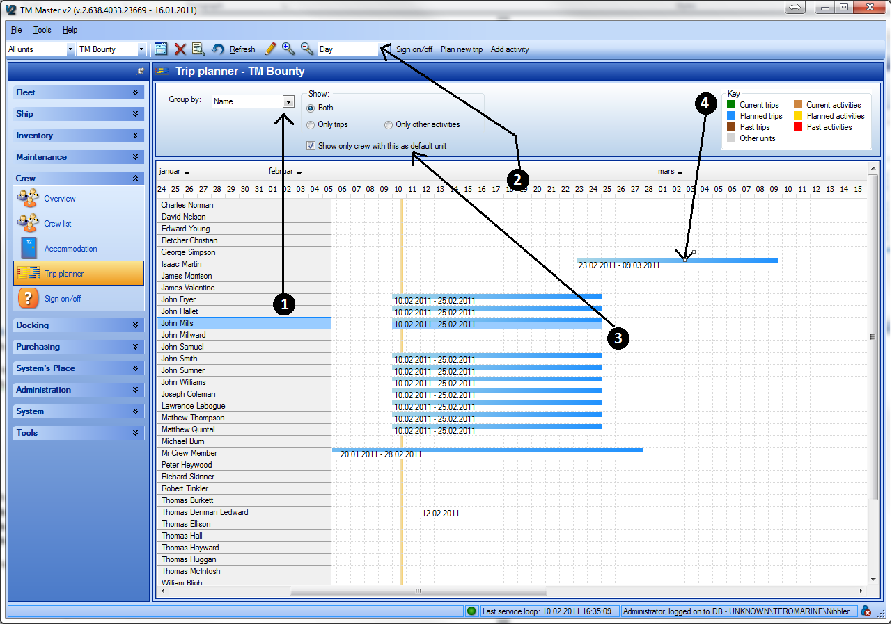
Grid:
- Crew members are listed vertically, they are by default listed alphabetically. You can group the names on the crew members “Crew type”, by using the “Group by” selection box.
- A time line is shown horizontally. You can change the timelines details, by switching between “Day, ”Week” and “Month” using the selector in the top menu. The Yellow vertical line in the grid is indicating today’s date.
- In the cross sections between crew member and the timeline, the trips and activities are shown as coloured lines. What the different colours represent are shown in the ledger in the top right corner. In the menu ribbon you can select to show either only “Trips”, “Only Other activities” or “Both”. You can also exclude all crew members not part of the default vessel crew. You can make changes to crew members’ planned trips or activities in this view by clicking the [Edit in grid] button (icon: Pencil). Then selecting a trip and moving it in time, or selecting the edge of the “trip” line and adjusting the trips start or end. By double clicking the line you will open the trip in the trip dialog.

- The ledger explains what the different colours represent.
- Green: Current active trips
- Blue: Planned trip
- Dark brown: Past trip (history)
- Gray : Trips on other units (planned, current, past )
- Light brown: Current activities
- Yellow: Planned activity
- Red: Past activities.

How to link a TM Master v2 user to a crew member?
There are 2 ways of linking a crew member to a user account, they are as follows:
To link a crew member to a User Account.
- Click [Crew][Crew list]
- Double click the crew member you want to link to a user account.
- Click the [Connect a user to this crew] (in the view menu) and select the crew member’s user.
- Click [OK]
To link a User Account to a crew member, do the following:
- Click [Administration] [Users]
- Double click the user you want to link to a crew member.
- Click the [Connect a crew to this user]
- Select the Crew member you wish to link it to.
- Click [OK]
When a crew member is linked to a user account, the system will be able to show additional information in the users, personal dashboard. (The module [[Username’s] place])
- Each individual crew member can be given access to his/her crew record
- The crew member will be able to enter “Hours of Work/Rest” information.
- The crew member can edit his own “custom declaration” records.
- In the user’s private dashboard “[<User name’s> place] jobs linked to the crew members crew type will be listed.
- When signing out jobs, the Crew name will be used in the “Sign out by” record, not the “user name” which is used if not linked.
- The crew member will be able to see any work permits currently pending for approval, by a crew member of his/her crew type.

How to update your own crew information?
In order to update your own crew record, or other crew related information, such as “Hours of Work/Rest” and “custom declaration” some configurations must be done by the administrators of the system.
- Your TM Master v2 user account (login) must be linked to your “Crew member record”.
(Described in: How to link a TM Master v2 user to a crew member?)
- The “User group” your user account is a member of will need to have the appropriate user rights.
(Described in : How to configure user rights to allow users edit their own crew records.)

- Click [<User name>’s place] [<Username>’s crew]
(<Username> will be your user account’s “first name")
- How to change the different aspects of your crew information is described in the other chapters in this document.

Your crew record will appear. The information made available and editable here may differ, since the administrators can configure your access level to these records.
- No access: You will be unable to see any crew information.
- Read access: You will be able to only read the information on your crew record.
- Change access: You will be able to update the information
- Custom declaration: You can update the “custom declaration” values, but unable to see any of the other information
- Edit Hours of work records: You can edit your own timesheet records.
- Edit Next of Kin. You can see, edit and add next of kin records for your crew record.
Combinations are also possible. For example “read” access to crew record, but change rights on custom declaration and hours of Work/Rest.
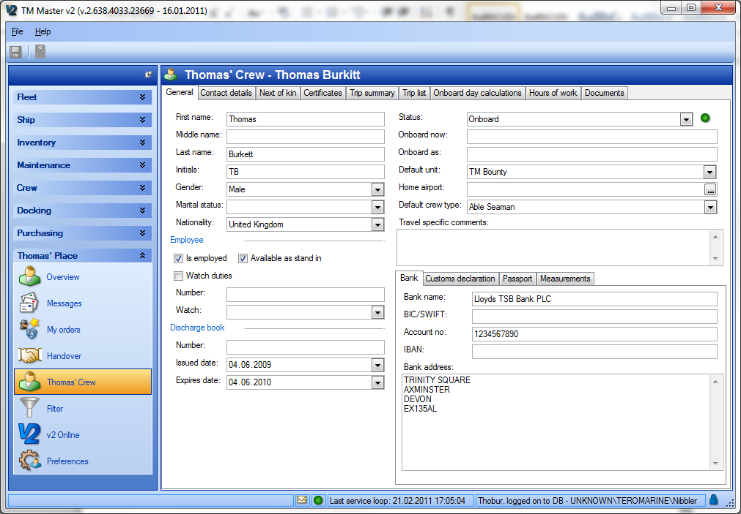

The Timesheet detail view

The timesheet detail view allows users to review and enter work hour entries.
The view is split into four panes.
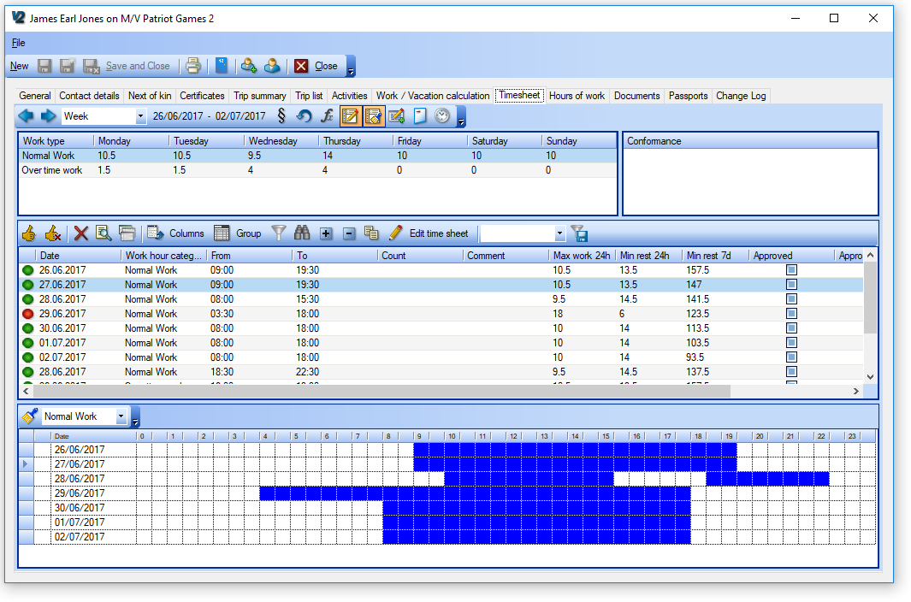
Summary Pane | The upper left pane showing total hours registered for the crew member for the selected date range.
Conformance pane | The upper right pane showing descriptions of any breaches of regulations for selected days
Timesheet pane | The middle pane showing the list of timesheet entries
Paint Pane | The Lower pane showing a graphical representation of time based entries

How to find the timesheet detail view
The timesheet function can be accessed from two different places in the TM Master V2 program (depending on user rights)
- In the crew module
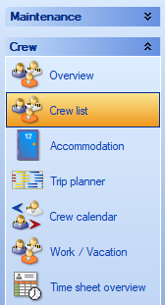
- Select [Crew] [Crew List] on the main side menu
- Double click a crew member
- Select the “Timesheet” tab

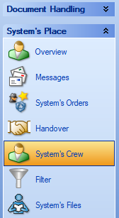
- In the My Place module

- Select My Place My Crew
- Select the ”Timesheet” tab (if more than one tab is available)

How to add work entries in the timesheet pane
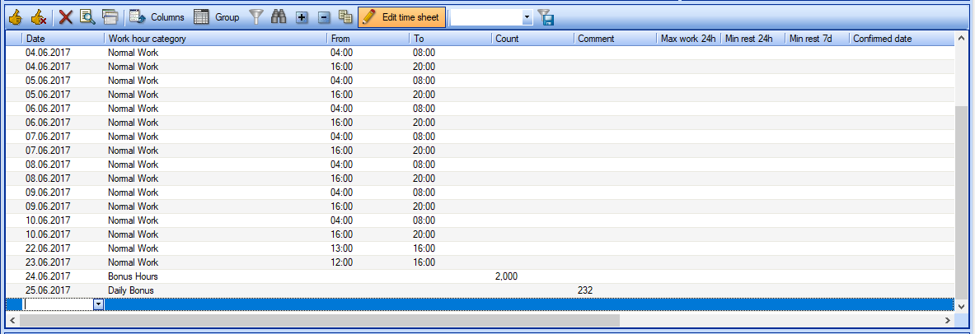
- Click the [Edit Time sheet] button on the toolbar of the time sheet pane
- Click in the first empty line of the grid
- Set the date
- Set the ‘Work hour Category’
- Enter the times or count accordingly
- Either
  - Click on the next empty line to add another entry and save the one you’ve just entered.
Or
  - Click the ‘Edit Time Sheet’ button again to save the entry.

Tip #1: While editing the time sheet grid, pressing the [Enter] key will move the currently active cell one place to the right.
Tip #2: When entering times in the ‘From’ and To’ columns, it is not necessary to type the semi-colon. For example, 12 o’clock can be typed simply as ‘12’ or ‘1200’, both will be accepted.
Note: For point 5 of this procedure, which column(s) you need to fill in depend on which ‘Work Hour Category’ is chosen. If a time based work hour category is chosen then, the times ‘From’ and ‘To’ columns need to filled in. If a count work hour category is chosen then the count column should be filled in. If a daily type work hour category is chosen then none of the columns need to filled in. Work hour categories are described in more detail in the ‘Work Hour categories section later in this manual.

How to add work entries in the paint pane.
- Click the paint button on the toolbar of the paint pane
- Select which “Work Hour Category” you wish to use from the drop down
- Click and drag in the paint grid to ‘paint’ the hours.
- Click the Paint button again to save the changes
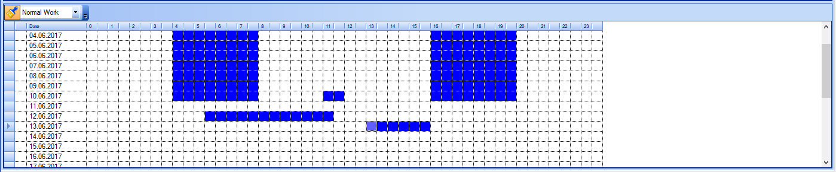
Note #1: Only time based work hour categories are available from the drop down in the paint pane.
Note #2: Time based entries entered within the paint pane will be automatically added to the timesheet pane and vice versa.

How to turn the Timesheet pane and the paint pane on and off.
- Navigate to the timesheet detail view
- On the uppermost toolbar, either
- Click this button to turn the timesheet pane on/off
- Click this button to turn the paint pane on/off

How to change the shown date range for timesheet.
- Navigate to the timesheet detail view
- On the uppermost toolbar, set the date interval using the drop down box
- Use the two arrow buttons to move the date range backwards and forwards as desired.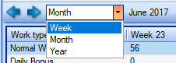

How to calculate conformance
- Navigate to the timesheet detail view
- Set the date range as desired
- Click this button to check conformance for the chosen date range

How conformance is shown
After clicking the ‘Recalculate Conformance’ button, a number of columns within the timesheet pane will be populated with Work Hour and Rest hour figures. In addition, to the left of each entry (both in the timesheet pane and the paint pane), a coloured ball will be shown to represent the different levels of conformance. These coloured balls can be one of five different levels.
 | Red | – A non-conformance (one or more of the regulations has been broken)
 | Yellow | – An exception has been utilized
 | Green/Yellow | – This entry is a contributing part of an exception period
 | Green | – This entry is in accordance with all regulations
 | Grey | – Recalculation of Conformance is required click [Recalculate] button
In cases where the ball is anything other than green or gray, there will also be text shown in the ‘Conformance’ pane detailing which regulations have been broken or which exceptions have been utilized.

How to add work periods for several days at once
To save time recording the hours, if the work schedule is similar over a period of time, the
[Add multiple workhours per day] can be used
- Navigate to the timesheet detail view
- Click the [Add multiple workhours per day] button on the uppermost toolbar
- In the new window, select the ‘Work Category’
- Set the dates ‘From’ and ‘To’
- Depending on work category chosen, either
  - Paint the hours you wish to add
Or
  - Enter the count number to be added
- Click ‘Add Work Hours’
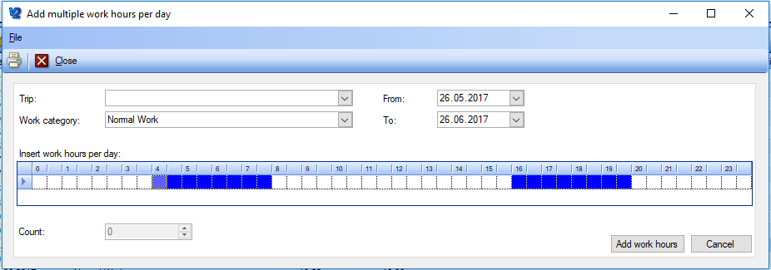
Note: Depending on the number of days selected, it may take some time to add all the entries. A progress bar will keep you updated.

How to generate the hours of rest report
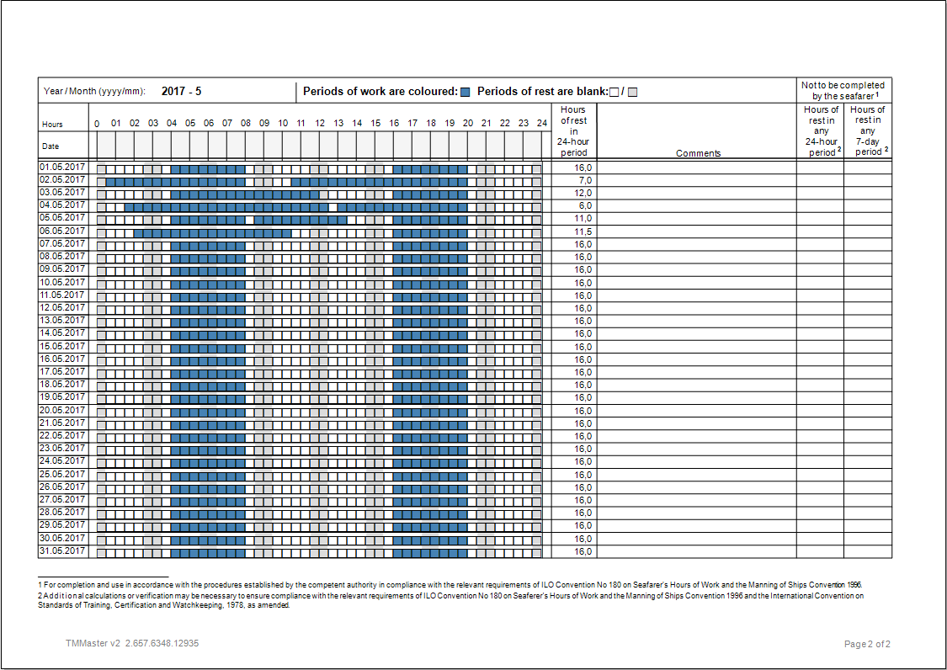
- Navigate to the timesheet detail view
- Click the [Report] button on the uppermost toolbar
- In the new window, select the month and year
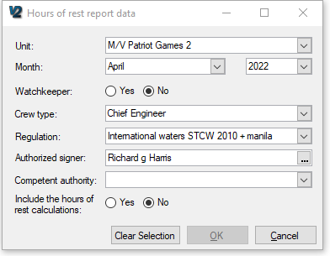

- Select the crew type (please see the note under)
- Select the Regulation
- Select the Authorised Signer (optional)
- Select the Competent authority (optional)
- Choose whether you want the system to fill in figures for the two calculated columns in the report (Yes/No)
- Click OK
- The two page report will now be generated, click print to obtain a hard copy.
- To save the report as a PDF, click File Export, Click OK and then select a location to save the file to.
Note: The crew type can be either the default crew type for the crew member, or the crew type that they are signed on as.
Note 2: To be able to Include the calculated figures for the two columns on the right of the report, you may need to contact Tero Marine for a special version of the report. This is due to the uncertainty of regulations regarding whether the system should fill out the figures for those columns or not.

How to view the change history for the timesheet
- Navigate to the timesheet detail view
- Set the date range as desired
- Click this button
- All change history will be shown for the chosen date range
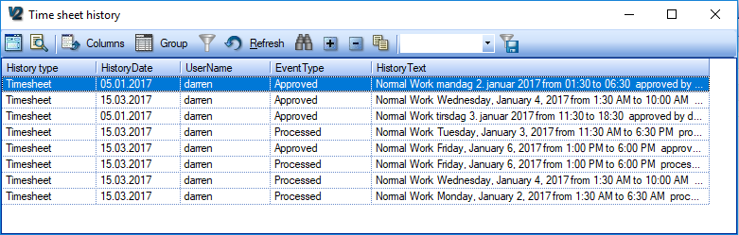
Note: Change history consists of all changes made to entries after they are confirmed. This includes when each entry is set as approved and processed, as well as cancellation of these statuses. This does not, however, include when confirmed is cancelled. In this particular case, the history for those entries that have confirmed cancelled, the history record is reset.

How to confirm work period entries
- Navigate to the timesheet detail view
- Select one or several lines in the timesheet pane grid
- Click the [Confirm entries] button on the toolbar
- You will then be asked to confirm various situations dependent on the data.
Note: This will confirm all entries on the same date and all previous dates (please see ‘Consistency in confirmation’ below), lock the date for editing (adding or changing entries) and perform a conformance recalculation.

How to cancel confirmation of work period entries
- Navigate to the timesheet detail view
- Select one or several lines in the timesheet pane grid
- Click the [Remove confirmation] button on the toolbar
- You will then be asked to confirm various situations dependent on the data.
Note: This will cancel the confirmation of all entries on the same date and all subsequent dates (please see ‘Consistency in confirmation’ below). It will also unlock the days for editing and delete any saved non-conformances for those days.

Consistency of confirmation:
It is not allowed to create a gap in the confirmation. By this, we mean that you are not allowed to confirm a day and have days before it which are not confirmed. The same logic is also used for Approval and setting entries as Processed. When confirming an entry, you will be informed of which days you are confirming and which (if any) non-conformities will be saved as a result of confirming the entries. (Please refer to the section about ‘Conforming, Approving and processing’, later in this manual for further details). This consistency is also necessary when cancelling confirmation, all days after the chosen date will also have their confirmation cancelled. Consistency is necessary due to the nature of Hours of rest calculation and the need to record non-conformances.

The TimeSheet overview
The timesheet overview allows you to review the total number of timesheet entries of different types for a given date range, as well as the total number of non-conformances and exceptions based on the regulations in force (upper pane).
Approval of timesheet entries and setting them to processed is carried out from this view (lower left pane).
Any Non-conformances are also described in the lower right pane when the appropriate dates are selected in the lower left pane. The timesheet overview can be accessed both from the main Fleet side menu (office only) and the Crew module main menu.
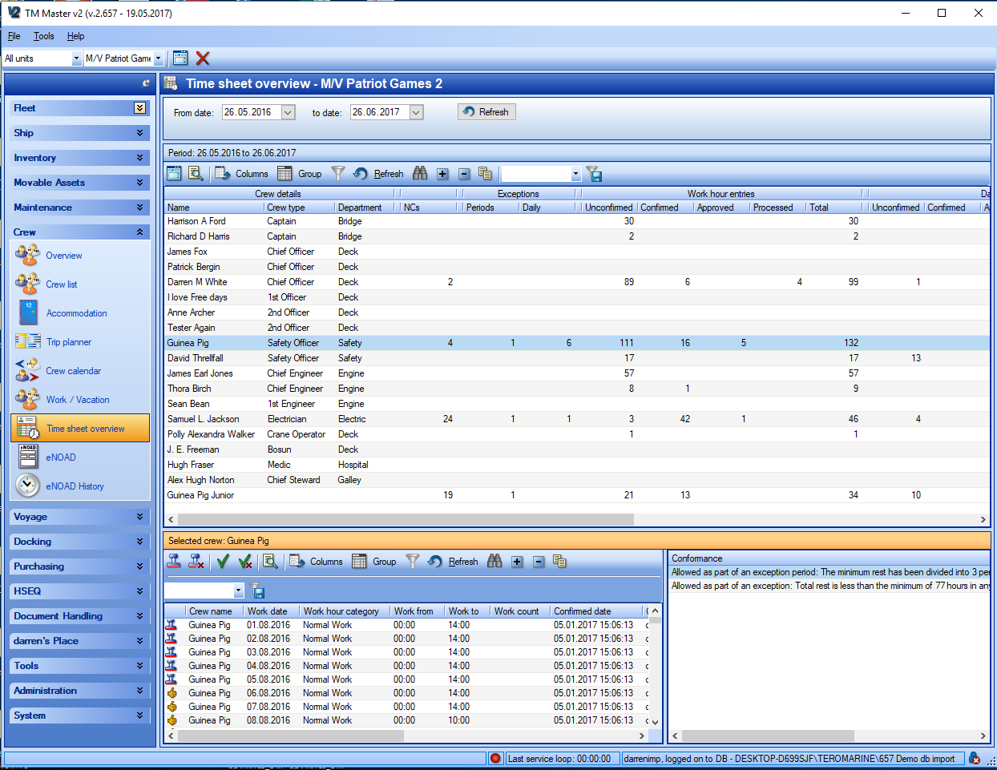

How to review timesheet data in the Timesheet overview.
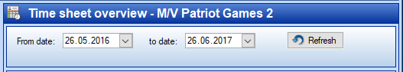
- Navigate to the timesheet overview
- Set the From and To dates
- Click Refresh

Tip: All the data displayed in the time sheet overview grid can be copied out to an excel sheet. Select the data you wish to copy, right click and select ‘Copy content to Clipboard’. You can then paste the data directly into an empty excel sheet.

How to Approve work period entries
- Navigate to the timesheet overview
- Set the From and To dates for the desired date range
- Click Refresh
- Select the crew member(s) you wish to approve entries for in the upper pane
- Select the entries in the lower grid that you wish to approve
- Click the [Approve selected entries] button on the lower left toolbar
- Confirm the approval in the new window
Note: Only entries which have been ‘Confirmed’ can be approved. Attempting to approve unconfirmed entries will not affect them. Approving an entry will automatically approve all other entries for that day and all those on previous days to maintain consistency. (Please refer to the section about ‘Conforming, Approving and processing’, later in this manual for further details)

How to Set work period entries as processed
- Navigate to the timesheet overview
- Set the From and To dates for the desired date range
- Click Refresh
- Select the crew member(s) you wish to process entries for in the upper pane
- Select the entries in the lower grid that you wish to set as processed
- Click the [Set to Processed] button on the lower left toolbar
- Confirm the approval in the new window
Note: Only entries which have been ‘Approved’ can be set as ‘Processed’. Attempting to process unapproved entries will not affect them. Processing an entry will automatically process all other entries for that day and all those on previous days to maintain consistency. (Please refer to the section about ‘Conforming, Approving and processing’, later in this manual for further details).

How to set up Timesheet for the fleet
Before Time sheet can be used by all users to maintain their work hours and hours of rest records, a number of steps have to be carried out at the office installation to prepare the system for use.
- Import a Time Sheet regulation set
- Set the default regulation set date range
- Set the regulation set date range for individual units
- Populate the ‘Work Hour Category’ code table
Each of these is handled in detail below. Regulation sets are provided by Tero Marine as an xml file containing the regulations for hours of work/rest which are applicable for your vessels. These requirements can vary according to flag state and trading area, but most companies conform to one or many international rule sets recommended by IMO. Please contact Tero Marine for more information.

How to Import Time Sheet regulations

- Go to [System] [Settings] and select the “Time Sheet Regulations” tab
- Click this [Add Regulation] button on the toolbar
- In the new window, click this button [Import XML] on the toolbar
- Navigate to the file you have received from Tero Marine and select it
- The file will now import and the regulation structure will show in the window
- Click Save and close

How to Set the default regulation set date range
- Go to [System] [Settings] and select the ‘Time Sheet Regulations’ tab
- Double click on the regulation set in the grid
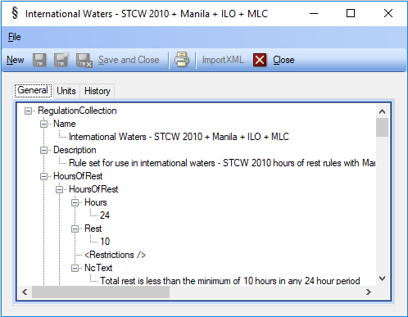
- Select the ‘Units’ tab
- Click the [Add to Unit] button on the toolbar
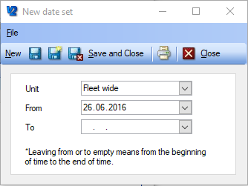
- In the new window, select ‘Fleet wide’ in the unit drop down
- Set the ‘From’ date to today or before
- Click save and close
Note: it is not necessary to set the ‘to’ date, as this is effectively the default regulation set for all instances where dates are not covered by other regulations.

How to Set the regulation set date range for specific units
- Go to System Settings and select the ‘Time Sheet Regulations’ tab
- Double click on the regulation set in the grid
- Select the ‘Units’ tab
- Click the [Add to unit] button on the toolbar
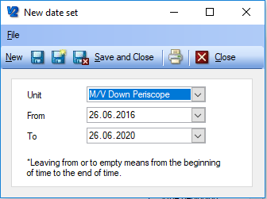
- In the new window, select the desired unit in the unit drop down
- Set the ‘From’ date to the desired start date for that particular unit
- Set the ‘To’ date to the desired finish date for that particular unit.
- Click save and close
Note: if all the vessels in the fleet are to always use the same regulation set, then it is only necessary to set the default regulation set (you are not required to specify date ranges for each unit)

Reference Section

How to set user rights in the Crew module?
You will need to log on with a TM Master v2 admin enabled account, in the office to perform the following.
- Click [Administration] [User groups]
- Select the group you wish to set user rights for.
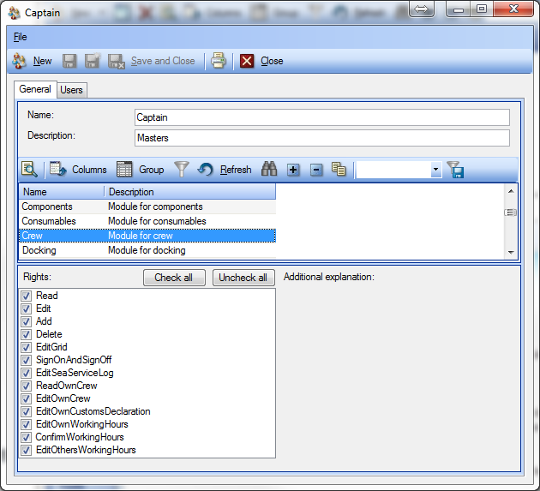
- Select “Crew” in the module list.
- Tick the user rights you want to assign to the selected group
  - Read – Allows the user to open and read all crew information.
  - Edit – Allows the user to change all crew data.
  - Add – Allows user to add new crew members.
  - Delete – Allows user to delete crew members .
  - EditGrid – Currently not active
  - SignOnSignOff – Will allow user to sign a crew member on/off a vessel.
  - EditSeaServicelog – Will allow user to edit previous, active and planned trips.
  - ReadOwnCrew – Will allow user to access (read) all his own crew information in the personal dashboard ( [<user name>’s place] [<username>’s Crew] )
  - EditOwnCrew – Will allow the user to also make changes to all his own crew data, in the personal dashboard.
  - EditOwnCustomsDeclaration – Will give the user access to only the “Customs declarations” tab found on the users crew record, and allow him to update it.
  - EditOwnWorkingHours – Will enable the user to register his own “hours of work” through the personal dashboard.
  - ConfirmWorking hours – Will enable the user to [Confirm] other crew members working hours.
  - EditOtherUsersWorkingHours – Will allow the user to make changes to other crew members hours of work, entries.
  - AddCertificate – Will allow the user to add and remove certificates to/from Crew members. It also controls whether the user can see crew certificates in the Inventory Certificates module
  - SeeCrewFromOtherUnits – This controls whether the user can see crew members that are assigned to other vessels in the database. This information is available in certain overviews within the crew module throughout the fleet.
  - PlanTrip – This will allow the user to plan trips
  - SeeCrewCalendar – This controls access to the Crew calendar view
  - VacationAdjust – This will allow the user to add and edit Manual Leave Adjustment records.
  - AddActivity – This will allow the user to add and edit activity records for all crew records.
  - SeeInactiveCrew – Allows the user to see crew records which are set as inactive. This user right only applies to viewing the crew module on unit installations
  - EditOwnNextOfKin – Allows the user to read, edit and add Next of Kin records for their own crew record in the ‘My Place’ module
  - CanViewBank – Allows the user to view the details contained within the Bank tab for all crew. Note removing this user right also removes the relevant columns from grid overviews.
  - CanEditWorkDays – Allows the user to edit the work days settings for crew members.

How to add crew related codes?
TM Crew has some crew specific code tables. Code tables are the source of the different selection boxes also called drop down boxes. Codes are only possible to add at the office installation, and are replicated to all vessels. You will need administrator user rights to add codes. Adding crew codes is done in the same manner as other codes. It is mentioned in this document to enable you to see which code tables are used by TM Crew.
- Click [Administration] -> [Codes]
- Select the code table you wish to edit or add codes.
The code tables used within TM Crew are:
  - Airport –Used as a setting to register the crew members home airports
  - Cabin type – Used to categorize cabins
  - Country – Used to define a crew member’s nationality.
  - Crew activity – Used as to categorize a crew member’s different activities.
  - Crew type – Used to describe what type of crew each crew member is.
  - Event – Used to define the emergency event types used for muster stations
  - Location Type – Used to define a location as a Deck when adding a deck in the Location module
  - Marital status – To describe a crew members marital status
  - Parameter Groups – Can be used to define several groups for custom fields to be used on crew records
  - Parameters: Crew – This is used to define custom fields for crew records
  - Relationship – Used to describe the relationship between crew member and next of kin
  - Role – Names of muster station roles
  - Side – Used as a location indicator for cabins and muster stations (ship side)
  - Trip plan – used to indicate which rotation different crew members are part of
  - Watch – You can assign a crew member to the available “watches”.
  - Work hour category – Used to define the work hour categories for the Timesheet function.

- Click [New] at the top left in the menu bar, once the code table you wish to add a code for is selected.
- Enter the Code you wish to use, each code must be unique, duplicates are not allowed, and the code value can’t be changed once it has been saved.
- Add the name of the code. It is the code name which is used in the different selection boxes, and used in the program grids. The name can be altered after the code has been saved. Changing a code’s name will be reflected in all the places the code has been used.
- Adding a number in the sort order field will alter the sorting of the list in the selection boxes. The list is by default sorted alphabetically.
- Deleting codes which have been used in the system, is not a good idea, doing so will leave the records using the code without a proper name for the code. However, if you want to remove a code from a selection box, you can do so by removing the “tick” in the “show in list” check box.

Crew Module – Work & Leave Calculation.
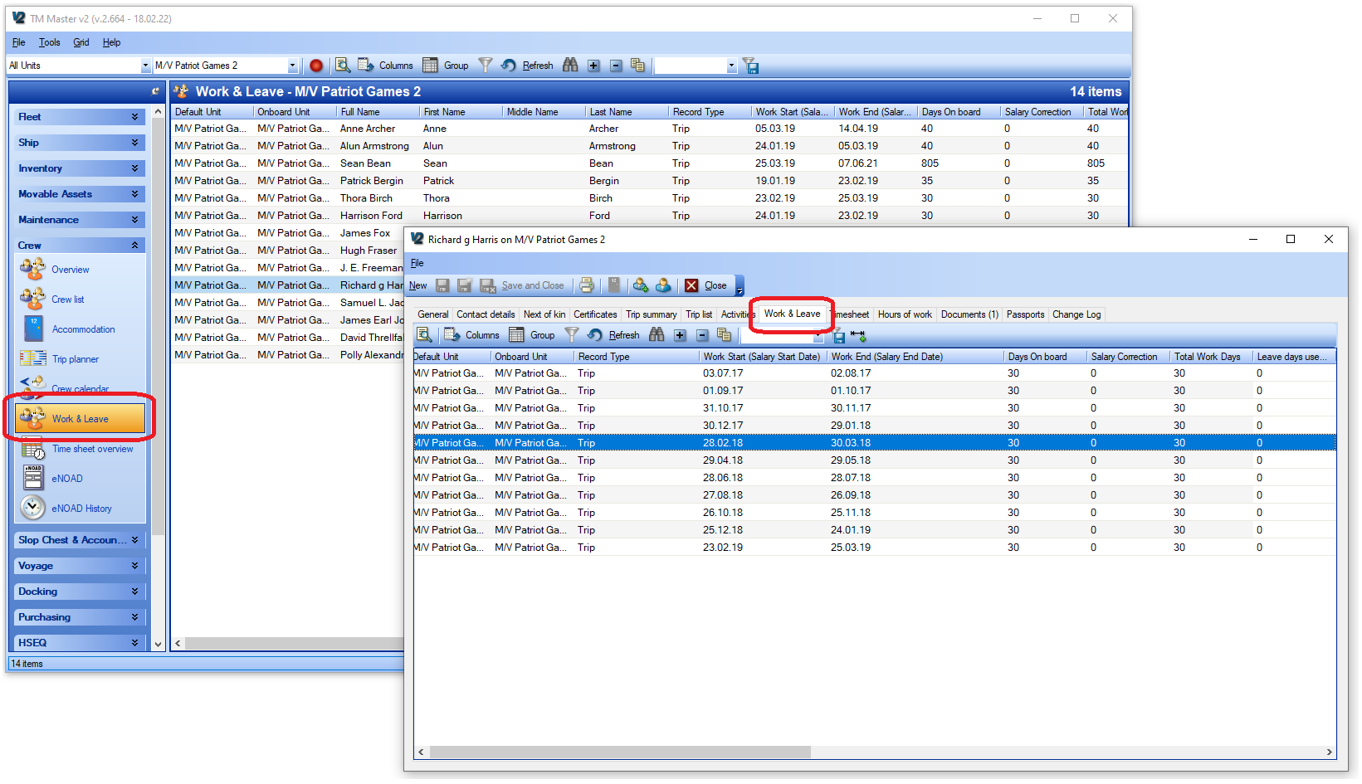
The Work & Leave calculation in the Crew module is a live running calculation of leave earned from trips and qualifying activities registered for each crew record. It is possible to define a leave earning ratio (how many days leave are earned for each day worked) for each trip and/or activity registered to allow for different contract conditions on a trip-by-trip basis. There is also the facility to apply manual adjustment records for the purpose of adding or subtracting earned leave for circumstances such as ‘cashing in’ leave.

Manual Adjustments for Work & Leave
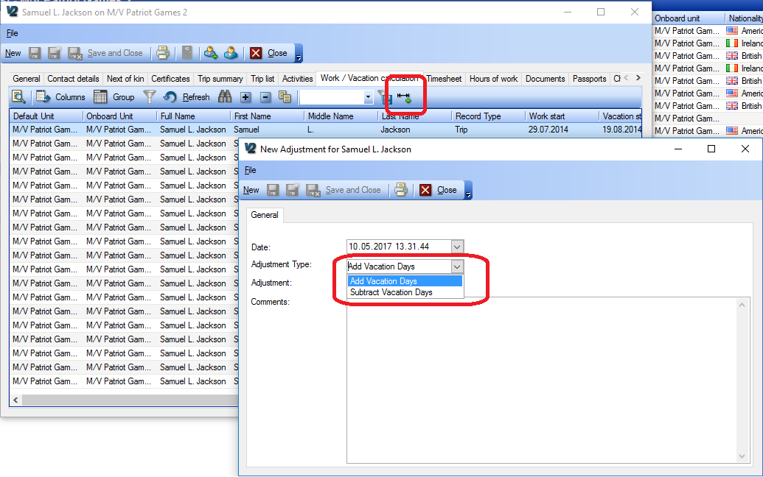
Manual Adjustments are basically just the addition or subtraction of Leave days
These can be used for a number of adjustments such as adding bonus Leave, transferring Leave from previous work or registering that Leave has been ‘Cashed in’.
When applying a manual adjustment, it is mandatory to write a comment.
A new user right called ‘VacationAdjust’ has been created for the purpose of controlling if a user is allowed to add manual adjustments or not.

How the Leave totals are calculated
Leave earned for each trip or work activity (please see ‘Activities’ below) is calculated based on the number of work days that has been calculated for that trip or activity.
The total work days for a trip or activity is defined by the difference between the Salary Start Date and the Salary End Date for each trip. This can however be affected by a global setting (see ‘Calendar Day setting’ below) which decides whether all the dates covered by a trip are counted as work days or if just the difference in dates is used.
From the total work days, the Leave Earned is calculated based on the ratio of ‘Default contract period’ to ‘Default Days on Leave’. These values can be set for each individual trip/activity (to allow for variations in contract over time), but default values can be set for each individual crew member, as well as for each individual unit within the fleet. This results in the following calculation;
Leave Earned = Work Days * (Default Days on Leave / Default contract period)
For example, if a seafarer has a contract that they earn 2 weeks of Leave for every 4 weeks that they work then
Default Contract Period = 28 days
Default Days on Leave = 14 days
If the seafarer then works a trip that is calculated as 20 days;
Leave earned = 20 * (14 / 28) = 10 Days Leave.
If neither Default days on Leave or default contract period are filled in for a trip /activity, the Leave days earned will not be calculated for that trip /activity. This is indicated by red X’s in the relevant column of the Leave calculation
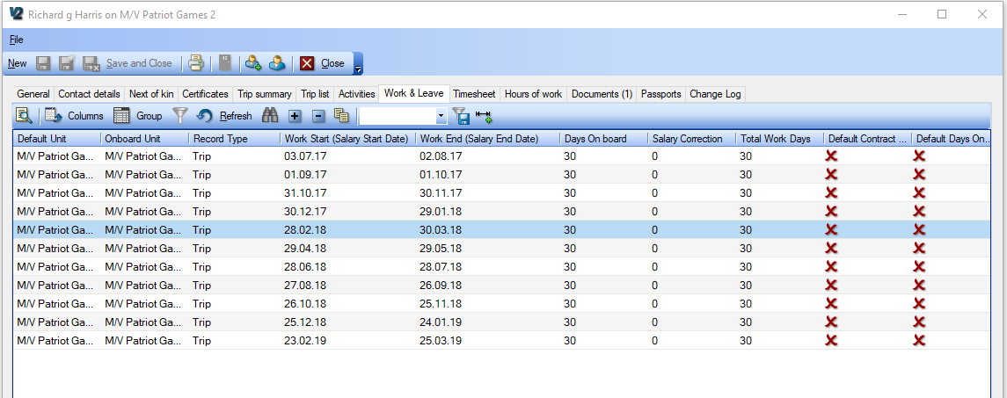

How Activities affect the work & leave calculations
It is possible to define crew activities as either Work, Neutral or Leave. This is done in the Administration Codes module within the ‘Crew activity’ code table.
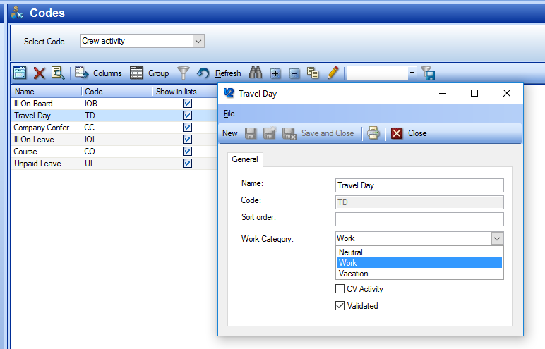
Activities defined as ‘Work’ will be shown as part of the Work / Leave calculation, will be counted as work days and will earn Leave according to the contract period / Leave days ratio.
Activities defined as ‘Neutral’ will be shown as part of the Work / Leave calculation, will be counted as work days, but will not earn Leave
Activities defined as ‘Leave’ will not be shown as part of the Work / Leave calculation, will not be counted as work days, and will not earn Leave

The Calendar Day Setting for Work & leave
There are two global system settings in the System Settings module, which have an influence on the way that the number of work days for each trip / activity is calculated.

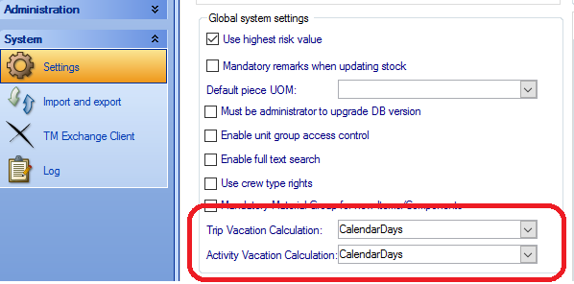
One setting is for the trips, the other is for activities. Both have two options
- Date Difference
- Calendar days
The ‘Calendar Days’ setting will include all dates that a trip / activity is part of, whereas the ‘Date Difference’ setting will count the difference between the dates. In most cases the difference between these two calculations will be that the calendar day setting will increase the number of work days by 1 per trip / activity and subsequently decrease the number of Leave days used between trips by one (for each Leave period). For example, a crew member that does 2 trips in january - from Monday 02.01.2017 12:00 to Friday 06.01.2017 12:00 and from Monday 09.01.2017 12:00 to Friday 13.01.2017 12:00
Date Difference calculation:
Trip 1 = 4 work days (13 – 9)
Leave days used between Trip 1 & Trip 2 = 3 days (9 - 6)
Trip 2 = 4 work days (13 – 9)

Calendar Day Calculation:
Trip 1 = 5 work days (13 – 9 + 1)
Leave days used between Trip 1 & Trip 2 = 2 days (9 – 6 – 1)
Trip 2 = 5 work days (13 – 9 + 1)

WARNING: The overall difference between these two calculation methods will become quite large when used with crew members that perform a lot of short trips /activities.
This setting also affects how the ‘Days on board’ are calculated, adding days on board in exactly the same way.
There are a few special cases within this rule set that have been taken account of, but the only one worth mentioning is the ‘One Day Rule’. This is where a trip or activity starts and ends within the same day. This will count as 1 work day regardless of which setting is applied.

Unit Overview for Work / Leave
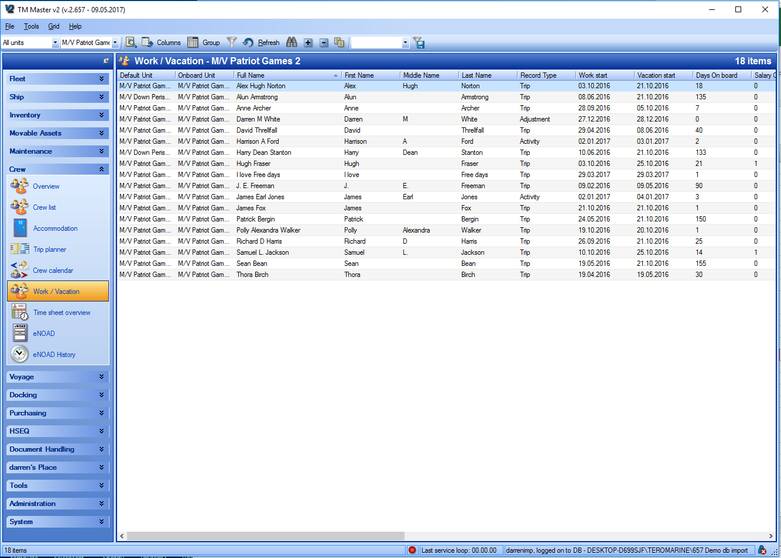

A work / Leave overview for each unit has been implemented. This overview shows the last contributing record for each crew member attached to that particular unit. From this it can be ascertained what the current work / balance is for every crew member for that unit without the need to open each crew record individually.

Information about Work Hour Categories (Timesheet)
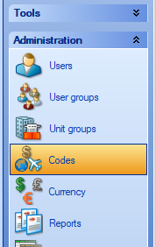
Work Hour categories are initially entered in the Administration Codes module (please refer to the general manual for how to administrate codes). Each work hour category can be set as one of three different ‘Registration Types’
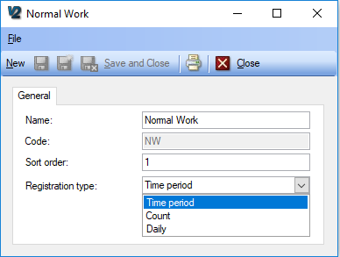
Time Period – typically used for normal work hour registration categories requiring a time from and to
Count – typically used to add bonus hours where those hours are not to be registered as ‘time worked’
Daily – typically used to categorise whole days.
Examples of these could be;
- Time Period – Normal Work, Overtime, Drill, Mooring etc.
- Count – Rope Handling Bonus, Bonus Hours
- Daily – Offshore days, Office Days, Off Pay Days, War Zone Days

Information about the time sheet user rights
There are a number of user rights to control the access and functions within the timesheet module. Some of these need to be used in conjunction with the user rights for the Crew module to gain full or partial access to crew records and their time sheets. Below is a list of the current user rights which are exclusively for the timesheet function (these may be added to in later versions)

Read | → | Can View the Timesheet records in the crew module (not necessary if the user has the Crew → Read user right)
Edit | → | Can Edit Timesheets for his/her own crew record
Add | → | N/A
Delete | → | N/A
EditGrid | → | N/A
EditOthers | → | Can Edit Timesheets for all crew records
ConfirmOwn | → | Can confirm own time sheet records
ConfirmOthers | → | Can confirm time sheets for other crew members. Note, this will not allow confirming of own records unless user can confirm own
CancelConfirmed | → | Can cancel confirmation of timesheet records
ApproveOwn | → | Can approve own timesheet records
ApproveOthers | → | Can approve time sheets for other crew members. Note, this will not allow approving of own records unless user can approve own
CancelApproved | → | Can cancel approval of time sheet records
ProcessOwn | → | Can set own time sheet records as processed
ProcessOthers | → | Can set time sheet records as processed for other crew. Note, this will not allow the user to set their own records as processed unless they have Process own.
CancelProcessed | → | Can Cancel processed for time sheet records
Admin | → | Can administrate time sheet regulations
BonusAdministration | → | User can add approved Count and Daily type time sheet entries for any dates for any user. This is intended for the administration of additions and bonuses to actual working hours.

Confirming, Approving and Processing
The timesheet function has been implemented with a 3 level approval system (Confirm → Approve → Process). The ability to set the levels and, if necessary, cancel them is totally controlled by the Usr rights detailed above. It is therefore possible to distribute responsibility for setting the approvals as you see fit. Here is a brief description of the levels

[Confirm]
This is normally done one crew member at a time from the time sheet detail view. However, it can be done from the timesheet overview as well (this has been added to make it easier for users that are responsible for confirming entries for other crew)
When a user confirms a timesheet record a number of different operations are set in motion.
The first is a consistency check, which will check if there are any unconfirmed entries on days before the selected one. If there are, then the user is informed that these will also be confirmed (as well as any other time sheet records for the same day).
The second operation is that the day will locked for editing. This will also stop any new records being added for the selected date (or previous dates). There is one exception to this rule and that is if a user has the ‘BonusAdministration’ user right. This enables a user to add ‘Count’ and ‘Daily’ time sheet entries for ‘locked’ days. The thought behind this is if bonuses and additions are administrated from the office, after time sheet hours have been confirmed and approved.
The third operation is that a ‘Hours of Rest’ conformance recalculation is performed. Any non-conformances that are found will be displayed to the user for additional confirmation. If confirmed these will be saved as part of the Non-Conformance history for that crew member. This history is then utilized in the time sheet overview to generate the total number of Non-conformances and exceptions for each crew member for specified date ranges.
Confirming is intended for each individual crew member to confirm that they are finished with data entry for those days that they have confirmed. However, as it is user right controlled, it is possible to designate any user to confirm someone’s time sheet entries.
Who confirms the time sheet record and when they have confirmed it, is logged within the system.

[Approve]
This can only be done from the timesheet overview.
A consistency check is also performed for approval so, if there are records before the selected one that have not yet been approved, they will also be approved. It is only possible to approve confirmed timesheet records. Any attempt to approve unconfirmed records will not affect those records.
Approval is just a stamp or flag for a timesheet entry. Which user has approved the entry and when they approved are logged within the system.
Approval is intended for senior officers to approve crew member’s timesheet entries as genuine. However, as it is user right controlled, it is possible to designate any user to approve someone’s time sheet entries.

[Processed]
This can only be done from the timesheet overview.
A consistency check is also performed for processed so, if there are records before the selected one that have not yet been processed, they will also be set as processed. It is only possible to set records as processed if they are approved. Any attempt to process unapproved records will not affect those records.
Processed is just a stamp or flag for a timesheet entry. Which user has processed the entry and when they set it as processed are logged within the system.
Processed is intended for office administration staff to set crew member’s timesheet entries as processed to indicate that they are either witnessed or transferred over to an external system (payroll for example). However, as it is user right controlled, it is possible to designate any user to process someone’s time sheet entries.
Note: From the date that a timesheet record has been set as processed, there is a 30 day window to cancel the status ‘Processed’ before the timesheet record is permanently locked.

Cancelling timesheet record approval levels.
Each approval level can be cancelled provided that the user has the appropriate user right to do so. The exception to this is processed if the record was set as processed more than 30 days ago.
Cancelling must take place in the reverse order, so for example – it is not possible to cancel approve for records that are set as processed.
There is also a consistency check involved in the cancellation of all approval levels. This means that cancellation of an approval level (confirmed, approved or processed) will result in the automatic cancellation of the same approval level for all records after the selected one.
For the cancelling of processed and approve, this simply involves the date and time of these levels being removed as well as change log record being created for the cancellation. However, for cancelling the confirmed level, a number of other operations are performed. For this situation, the change log history for those records is also removed, as well as any ‘Hours of Rest’ Non-conformance history that has been saved for those records.

