How to…. Catalogs

Contents

How to create a top-level catalog group (New Catalog) 2

How to create a sub-level catalog group 2

How to add a new catalog item to a catalog 3

How to add stock to a catalog item 3

How to withdraw stock from a catalog item 3

How to add a catalog item to a draft order 3

How to link a catalog item to a component 4

How to link a catalog item to a component job 5

How to link catalog items to components and jobs directly from an order 5

How the catalog query filter affects the item list 6

How to move a catalog item from one group to another 6

How to hide a catalog group for a specific unit (Office Only function) 7

How to show (unhide) a hidden catalog group for a specific unit (Office Only function) 8

How to export items to the excel update sheet (Office Only function) 9

How to Import updated items from the excel update sheet (Office Only function) 10

How to import New catalog items from the excel update sheet (Office Only function) 11

How to block (and unblock) catalog items 13

How to Edit unit specific fields in the catalog grid 14

How to find total in stock and total on order for the whole fleet 15

How to delete a catalog group 16

How to delete a catalog item 17

How to delete items ‘in use’ without needing to delete connections first. 17

User rights for catalogs 18

**Revised 27.04.2022**

## How to create a top-level catalog group (New Catalog)

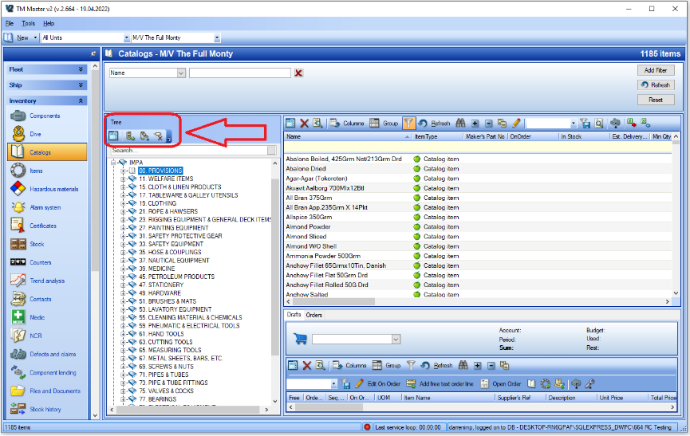

1. Click [Inventory] 🡪 [Catalogs]
2. Click [Add a root node to tree]  in the Catalog structure pane
3. Type a name for the group
4. Click [OK]

Note: It is also possible to add groups from the drop down ‘Tree’ Menu and the right click menu.

## How to create a sub-level catalog group

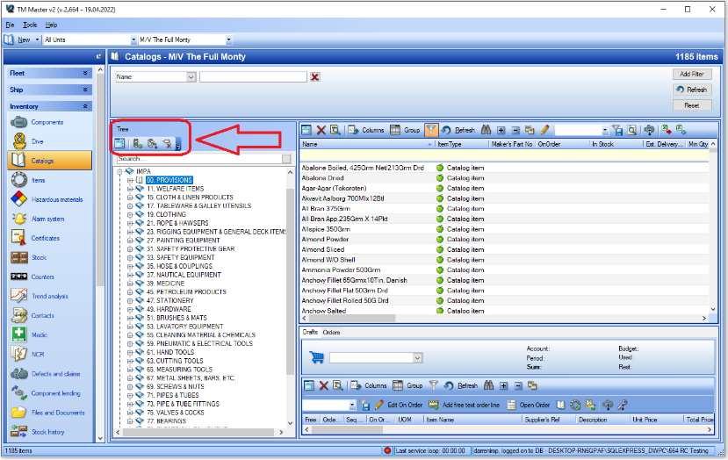

1. Click [Inventory] 🡪 [Catalogs]
2. Select an existing group in the structure pane
3. Click [Add a sub node to selected node]  in the Catalog structure pane
4. Type a name for the group
5. Click [OK]

Note: It is also possible to add groups from the drop down ‘Tree’ Menu and the right click menu

## How to add a new catalog item to a catalog

1. Click [Inventory] 🡪 [Catalogs]
2. Select the group in the structure pane that you wish to add a new item to
3. Click [New]  at the top left of the screen
4. Fill in the Name of the item and any other details you have.
5. Click [Save and Close]

## How to add stock to a catalog item

1. Click [Inventory] 🡪 [Catalogs]
2. Select the group in the structure pane that contains the item you want to add stock to
3. Right click the item you want to add stock to
4. Select [Add Stock]
5. Specify the quantity of stock and other details you have
6. Click [OK]

## How to withdraw stock from a catalog item

1. Click [Inventory] 🡪 [Catalogs]
2. Select the group in the structure pane that contains the item you want to add stock to
3. Right click the item you want to withdraw stock from
4. Select [Withdraw Stock]
5. Specify the quantity of stock and any other details you have
6. Click [OK]

## How to add a catalog item to a draft order

1. Click [Inventory] 🡪 [Catalogs]
2. Select the group in the structure pane that contains the item you want to add to a draft order
3. Right click the item
4. Select [Add to Draft] and either select an existing draft or [New Draft]
5. If selecting [New Draft], you will be asked to write a name for the new draft and click [OK]
6. Specify the quantity that you want to order
7. Click [OK]

## How to link a catalog item to a component

1. Click [Inventory] 🡪 [Catalogs]
2. Select the catalog that contains the items you want to link to components
3. Select the Item(s) you wish to connect to one or several components
4. Click [Connect to Component] 
5. Select one or more components to link the catalog item(s) to
6. Click [OK]

## How to link a catalog item to a component job

## 

1. Click [Inventory] 🡪 [Components]
2. Double click the component that has the relevant job
3. Select the ‘Jobs’ tab
4. Double click the relevant job
5. Select the ‘Items’ tab
6. Click [Add Catalog Item] 
7. Select the catalog that contains the item(s) you want to link to the job
8. Select the item(s) that you want to link to the job
9. Click [OK]
10. Specify the quantity required for each item for that particular job
11. Click [OK]

## How to link catalog items to components and jobs directly from an order

1. Click [Purchasing] 🡪 [Overview]
2. Locate the order that contains the items that you want to link
3. Double click the order
4. Select the ‘Order lines’ tab
5. Select the items in the list that you want to link
6. Click [Connect to Component]  or [Connect to Component Job] 
7. Select the component or component job from the list and click [OK]

Note: this function will not work for free order lines. (you will be informed of this if you try to link free order lines)

## How the catalog query filter affects the item list

Applying a query filter at the top of the catalog view will affect which items are shown in the item list pane.

In the example shown above, the item list will only show items which contain the text ‘ring’ in the name and have the item category ‘Paint’.

The query filter works in combination with the selection made in the structure pane, so selecting a group in the structure pane will limit the item list to only that group and the items that satisfy the query filter.

## How to move a catalog item from one group to another

1. Click [Inventory] 🡪 [Catalogs]
2. Select the catalog that contains the item you want to move
3. Select the Item in the item list
4. Drag and drop the item into the group structure where you want to move it to.

## How to hide a catalog group for a specific unit (Office Only function)

1. Click [Inventory] 🡪 [Catalogs]
2. Select the catalog group that you wish to hide
3. Right Click on the group and select [Hide catalog for..]

1. Select the Unit or Unit group that you wish to hide the catalog group for
2. Click the appropriate arrow button  to add the Unit or Unit Group to the ‘Hidden for’ list.

1. Click [Save and Close]

## How to show (unhide) a hidden catalog group for a specific unit (Office Only function)

1. Click [Inventory] 🡪 [Catalogs]
2. Right Click on any group in the structure pane and select [Show Hidden..]
3. You will then be shown which catalog groups are hidden for the currently selected unit

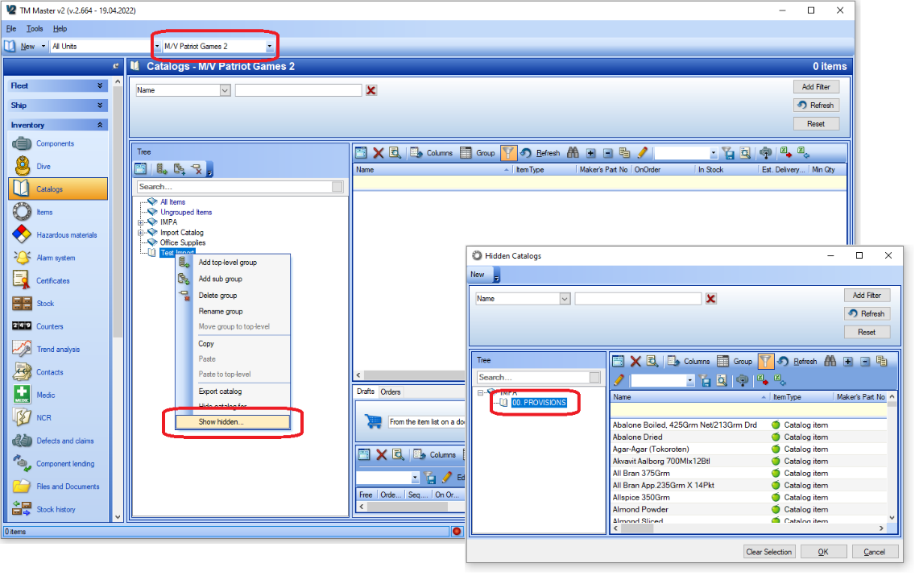

1. Select which group you want to Show (unhide) and click [OK]

Note: This action can also be done by using the ‘Hide catalog for’ method (see ‘How to hide a catalog group for a specific unit’ earlier in this manual) and just moving the appropriate unit or unit group from the right-hand side to the left-hand side using the appropriate arrow button . However, you will need to be viewing the catalog for a unit that does currently have access to the hidden group.

## How to export items to the excel update sheet (Office Only function)

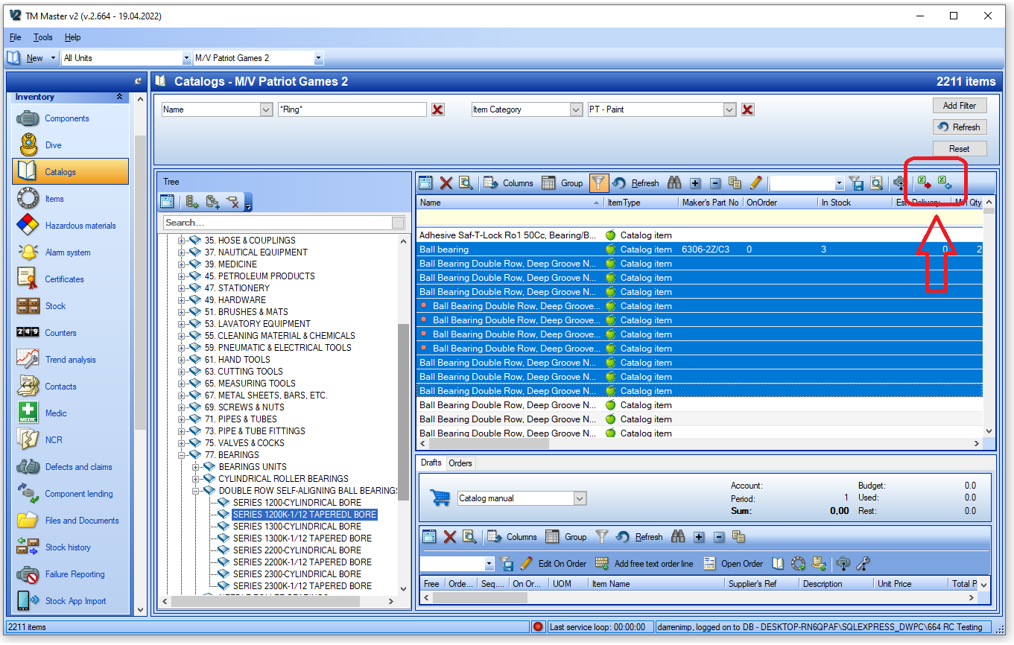

1. Click [Inventory] 🡪 [Catalogs]
2. Make a selection in the structure pane or use the query filter to find the items you wish to export
3. Select the items in the grid that you wish to export
4. Click [Export Item List to Excel] 
5. Click [Include Selected Items] in the dialog

1. Choose a location to save the excel file and Click [Save]

Note: the selected items will now be in the excel sheet, where you can change details in the available columns and import the changes.

## How to Import updated items from the excel update sheet (Office Only function)

1. Click [Inventory] 🡪 [Catalogs]
2. Click [Import Item List from Excel] 
3. Locate the file, select it and click [Open]
4. Tick the item updates that you wish to import

1. Click [Import]
2. If you have not ticked all the items in the list, you will be presented with a dialog

1. Click [Import selected items and Close] if you are finished making all your selections

Note: Items which have failed the quality check will be listed in the lower pane. It will not be possible to import these until the error has been corrected. Items can be edited directly in the grid after clicking the [Edit Grid]  button. As soon as the error has been corrected, the item will move to the upper grid.

## How to import New catalog items from the excel update sheet (Office Only function)

1. Click [Inventory] 🡪 [Catalogs]
2. Click [Import Item List from Excel] 
3. Locate the file, select it and click [Open]
4. Select the ‘New Items’ tab
5. Tick the new items that you wish to import

1. Click [Import]
2. If you have not ticked all the items in the list, you will be presented with a dialog

1. Click [Import selected items and Close] if you are finished making all your selections
2. You will then be asked if you want to show the new items on any of the units

1. Click [Yes] ****
2. Select which unit(s) you wish the items to be shown for in the Inventory 🡪 Items module and click [OK] ****
3. You will be informed when the new items have been imported, click [OK]

Note: Items which have failed the quality check will be listed in the lower pane. It will not be possible to import these until the error has been corrected. Items can be edited directly in the grid after clicking the [Edit Grid]  button. As soon as the error has been corrected, the item will move to the upper grid.

**** The item data will be imported whether you choose Yes or No. Choosing which units you want to show the items will just decide which Units will see the items immediately in the Inventory 🡪 Items grid

## How to block (and unblock) catalog items

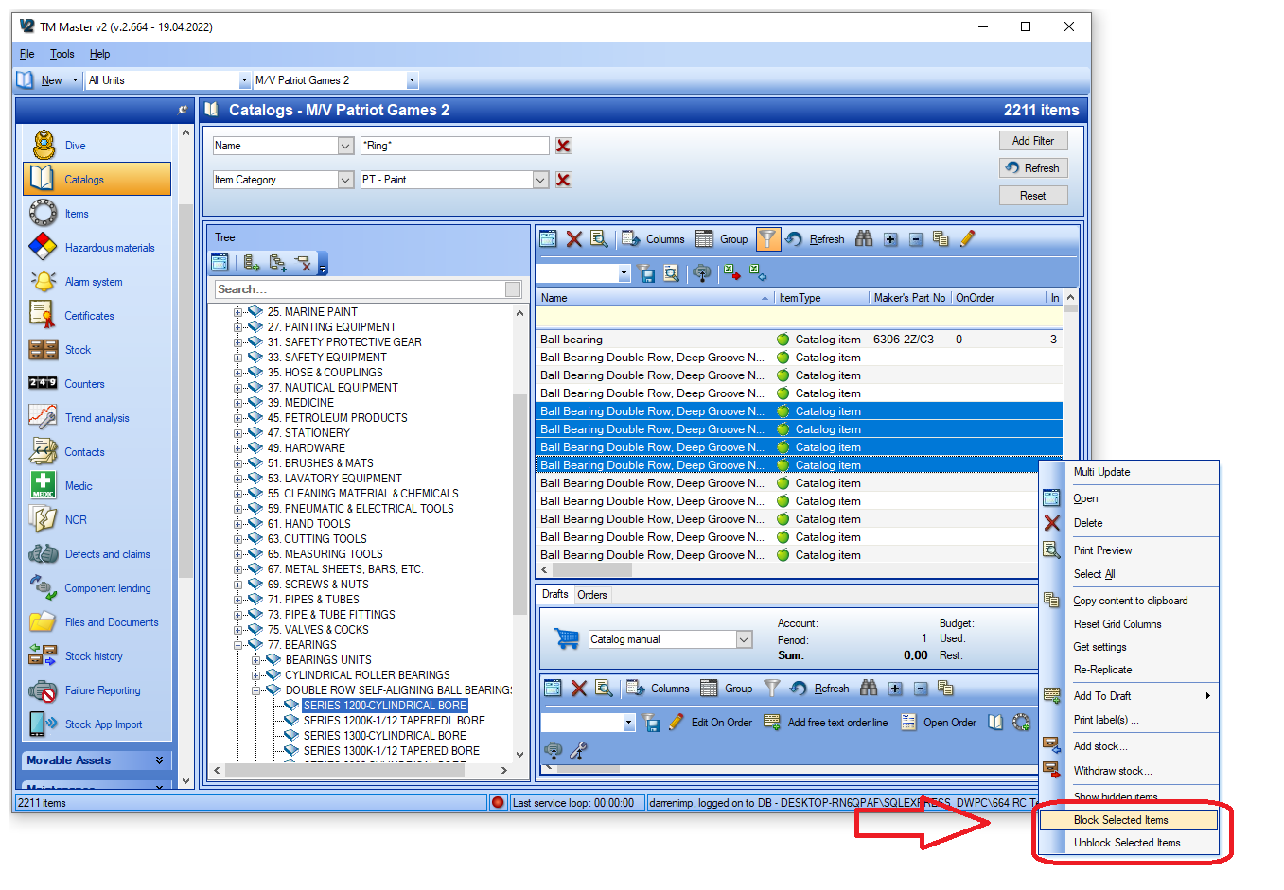

1. Click [Inventory] 🡪 [Catalogs]
2. Make a selection in the structure pane or use the query filter to find the items you wish to block
3. Select the items and right click
4. Select [Block Selected Items]
5. You will then be asked to write a reason for blocking the items. Write a reason
6. Click [OK]
7. Click [Refresh]
8. The items will now be displayed with a small coloured dot beside the name to indicate that they are blocked (see below)

Note: Blocked items cannot be added to a purchase order. Unblocking is done in exactly the same manner, but you need to select ‘Unblock Selected Items’ from the right click menu.

## How to Edit unit specific fields in the catalog grid

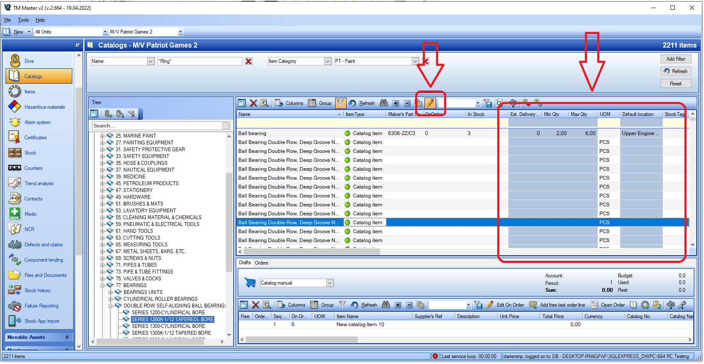

1. Click [Inventory] 🡪 [Catalogs]
2. Make a selection in the structure pane or use the query filter to find the items you wish to edit
3. Click [Edit Grid] 
4. The columns you can edit will now be coloured blue.
5. Edit accordingly and click [Edit Grid]  to save the changes

Note: This function is available to users who have the special ‘Implementor’ user right access and to normal users that have the rights to edit item unit fields.

## How to find total in stock and total on order for the whole fleet

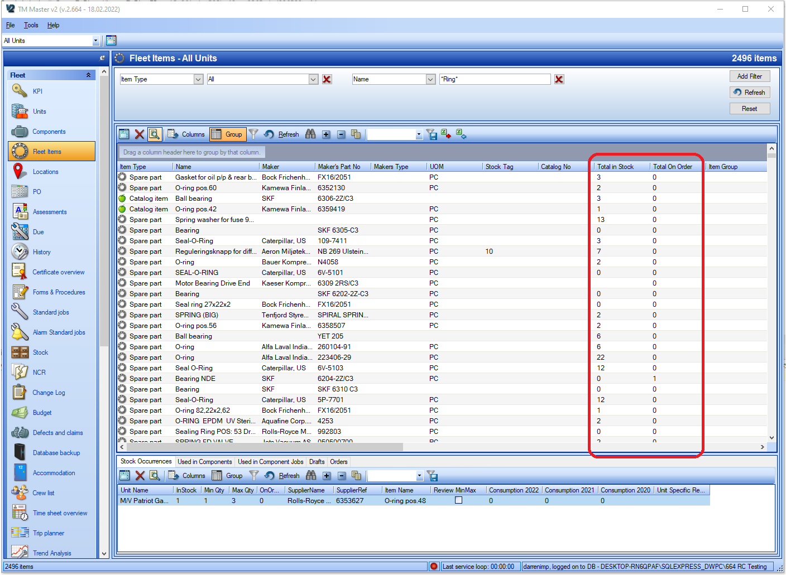

1. Click [Fleet] 🡪 [Fleet Items]
2. Set the filters at the top of the view according to find the item(s) you are looking for
3. Click [Refresh]
4. The columns ‘Total Stock’ and ‘Total On Order’ can be found in the grid and are total values for the entire fleet. Clicking on an item will show which units have the stock in the lower pane.

## How to delete a catalog group

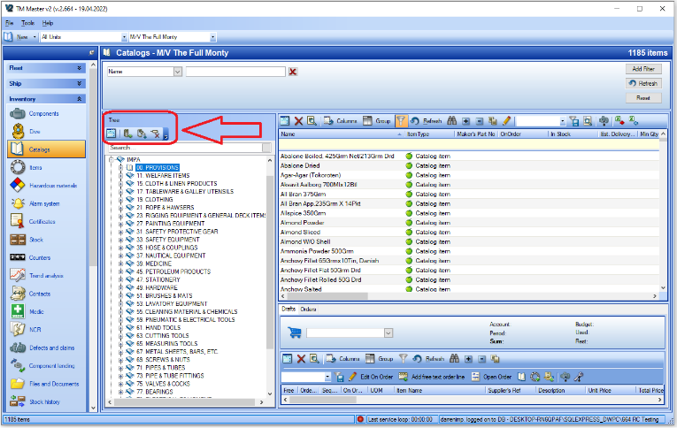

1. Click [Inventory] 🡪 [Catalogs]
2. Select an existing group in the structure pane
3. Click [Delete node]  in the Catalog structure pane
4. If there are items in the catalog group you will then be asked if you want to delete them or just set them to ungrouped, select the option you wish.

1. Click [OK]
2. If you select ‘Delete All Elements’ and some of the items are in use (connected to stock records or components for example), you will be asked if you want to ‘keep’ the items or ‘hide’ them. Select the appropriate option

Items that are in use cannot be deleted without removing the connections first.

Note: It is also possible to delete groups from the drop down ‘Tree’ Menu, and the right click menu.

## How to delete a catalog item

1. Click [Inventory] 🡪 [Catalogs]
2. Select the appropriate catalog group in the structure pane
3. Select the item that you wish to delete
4. Click [Delete the selected item]  in the Item list pane
5. If there are no links to the item, then you will be asked to confirm the deletion. Click [Yes]
6. If the item is ‘in use’ (connected to stock records or components for example), you will be asked if you want to ‘hide’ the item from the catalog. Select the appropriate option

## How to delete items ‘in use’ without needing to delete connections first.

Note: this function requires a dedicated user right and is only possible from two views in TM Master V2 – Fleet 🡪 Items and Tools 🡪 Catalog Cleaning

1. Click [Fleet] 🡪 [Fleet Items]
2. Set the filters at the top of the view according to find the item you wish to delete.
3. Click [Refresh]
4. Select the item that you want to delete
5. Click [Delete the selected item]  in the Item list pane
6. You will now be given a warning that you are about to delete and item in use, Click [Yes] if you still want to perform the action

## User rights for catalogs

Read – Allows the user to view Catalogs and catalog items in both overviews and detail views

Edit – Allows the user to edit Catalog Items central data**

Add – Allows the user to create new catalog items

Delete – Allows the user to delete catalog items that are not currently in use****

EditGrid – Not in use

EditItemUnitFields – Allows the user to edit the unit specific fields for a catalog item

SetHideForUnits – Allows the user to hide catalog groups and their contents for specific units (this function is only available at the office installation)

DeleteUsedItem – Allows the user to delete catalog items which are currently in use****

BlockUnblock – Allows the user to apply or remove the ‘Blocked’ flag for an item

ImportExport – Allows the user to utilize the Import/Export excel sheet for catalog items (this function is only available at the office installation)

EditComponentItemFields – Allows the user to edit the component link specific fields for catalog items

EditCatalogStructure – Allows the user to

DeleteItemUnit – Allows the user to delete the link between an item and a unit (only possible if links to components and stock have already been removed)

AddImage – Allows the user to add pictures to items

**If a catalog item is validated, it is not possible edit common data fields at vessel installations

****’In Use’ means that the catalog item is linked to units, stock records, components and/or component jobs