## How to install more than one TM Master V2 service on a single server?

1. Install TM Master V2 server service as normal.
2. Copy the service Programfolder (default : C:\Program files\TM Software\TM Master V2 Server\)
3. Past the folder in the C:\Program files\TM Software\ folder.
4. Rename the copied folder (e.g. TM Master V2 Server (ROV))
5. Double click **TmMv2ServerConnectionTool.exe** found in C:\Program files\TM Software\ TM Master V2 Server (ROV)\bin\   
     
   (ROV is just an example because this is mainly used for vessels with subsea and marine databases, and you can use other describing names here for your installation)

The Server Service connection dialog appears

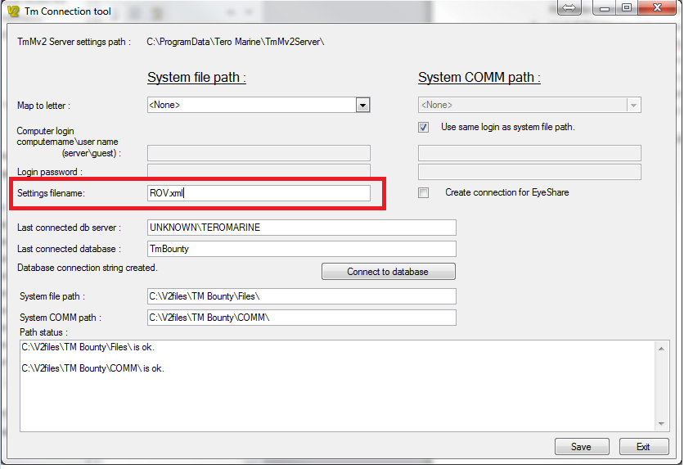

1. Change the “Settings file name” (e.g. ROV.xml) (indicated by red square in this document)
2. Also put in the new name in the box below called SubPath
3. Connect to the database you want the service to connect to, as with a normal installation.
4. Click [Save]  
     
   A new connection file is now saved in:  
   “C:\ProgramData\Tero Marine\TmMv2Server\” (Windows 7 and up)  
   “C:\Documents and Settings\All Users\Application Data\Tero Marine\TmMv2Server\” (Win XP)
5. Start **Powershell** as administrator and run the following command (this will of course need to be changed to fit your installation):  
     
   New-Service -Name "TmMv2Server(ROV)" -BinaryPathName """C:\Program Files (x86)\TM Software\TM Master v2 Server\bin\TmMv2Server.exe"" ROV.xml"
6. Start the Windows Register editor (Regedit)

Locate : HKEY_LOCAL_MACHINE\SYSTEM\CurrentControlSet\Services\[service name]

1. Double click the “ImagePath” key, and make sure that everything looks like the image below with   
   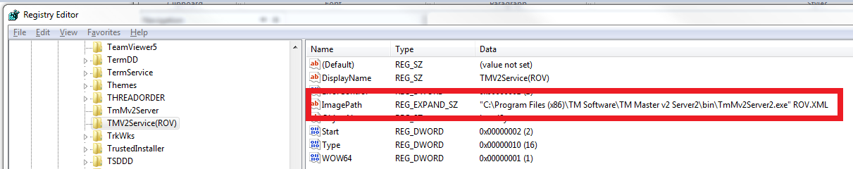In my example would be :  
   "C:\Program Files\TM Software\TM Master V2 Server (ROV)\bin\TmMv2Server.exe" **ROV.XML**
2. You can now open the “Service” console (found in administrative tools), and verify that you now can see the additional TM Master V2 service, and start it.
3. Verify in that the service is linked to the correct database by accessing the database using a TM Master V2 client, and check out the replication log (service log).

## How to configure TM Exchange when running more than one service?

Currently TM Exchange, when downloading and sending files, uses temporary folders. If TM Exchange is configured to send and download files on both systems, you risk the two services interfering with each other, since they will be using the same temporary folders.

The two systems should be configured with their own separate “System File“ and “COMM” path.  
I’ll give you an example of how it can be done. (It can be done in differently if desired, but the important thing is to keep file areas separated)

1. Create a share: e.g. \\Server\TMMV2Data\
2. Create a sub folder for each of the systems :   
   e.g. \\Server\TMMV2Data\Maritime and \\Server\TMMV2Data\ROV
3. Then create the “System File” and “COMM” paths for each of the systems

e.g. \\Server\TMMV2Data\Maritime  
\\Server\TMMV2Data\Maritime\COMM\  
\\Server\TMMV2Data\Maritime\V2files\  
  
\\Server\TMMV2Data\ROV\  
\\Server\TMMV2Data\ROV\COMM\  
\\Server\TMMV2Data\ROV\V2files\

1. Enter the corresponding paths into [System] ->[Settings] ->”General tab” for each system.
2. Select one of the system to be the “TM Exchange Master”   
   (e.g. the Maritime since this is the system already configured with TM Exchange)
3. Log on your selected system and click [System] -> [TM Exchange] -> “Rules” tab.
4. Add a new send rule, and make sure to enter the “ROV” system’s “comm” path in in the field labeled “Path”, and use the unit code for the ROV system in the file mask.   
   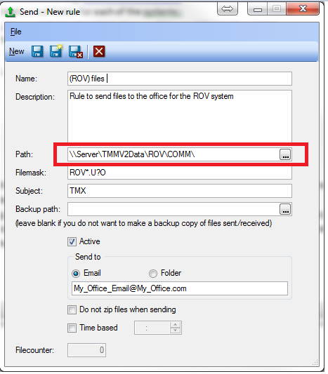
5. TM Exchange for the Maritime system will now check the “comm” folder belonging to the ROV system, and send any files fitting the file mask specified.
6. Create a new Receive rule for the ROV (also in the Maritime system), and again make sure you enter the ROV systems “Comm” path in the field labeled “Path”, and use the unit code set for the ROV system in the file mask.

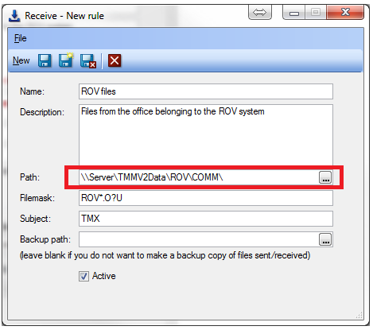

When TM Exchange now downloads files fitting the mask specified it will place it in the ROV system’s “COMM” folder.

At the office create a send rule that picks up the ROV units files, and sends it to the same address as the maritime counterpart uses.

Expiry